Disability:IN Greater Kansas City

2020 Year in Review
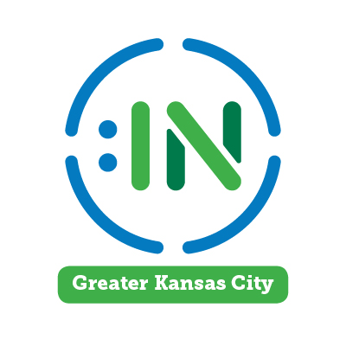
Elevating Disability Inclusion!
- EDUCATE our business community on proven strategies to advance disability inclusion in the workplace and marketplace.
- CULTIVATE relationships between business, community and academic partners to advance disability inclusion.
- ELEVATE inclusive practices and thought leaders so businesses become employers of choice for people with disabilities.
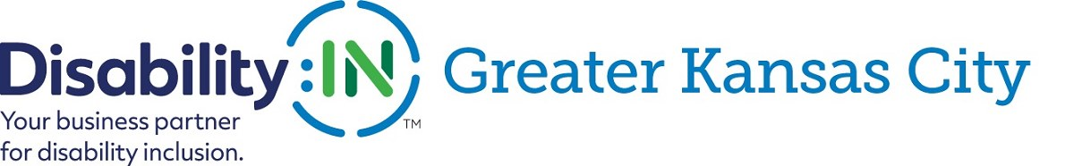
Educational Programs/Webinars:
- Culture Transformation: What HR and D&I Leaders Need to Know - Beth Butler/Disability:IN North Carolina
- Disability-Focused ERG/BRGs - John Robinson/Our Ability
- The Value of Disability Inclusion in Supplier Diversity - Philip DeVielgher & Cami Turcotte/Disability:IN
- A Closer Look at the Employee Lifecycle -Andy Traub/Allied InclusionWorks & Allied Global Services
- Celebrating the ADA 30th Anniversary - An Overview of its History and Looking Forward - Julie Brinkhoff/Great Plains ADA
- Inclusive Interviewing to Increase Your Diversity - Jill Webb/Disability:IN GKC
- How to Become a Leading Edge Hiring Manager - Unconscious Bias and Dispelling Myths & Misconceptions - Derrick Nelson/Commerce Bank & Darla Wilkerson/Disability:IN GKC
- Where to Begin! Getting Started with Disability Inclusion at Your Organization - Cara Pelletier/Kronos Incorporated and Ultimate Software
- Removing the Barriers: Making Your Web Sites Accessible to People with Disabilities - George Calvert/Jack Henry & Assoc.
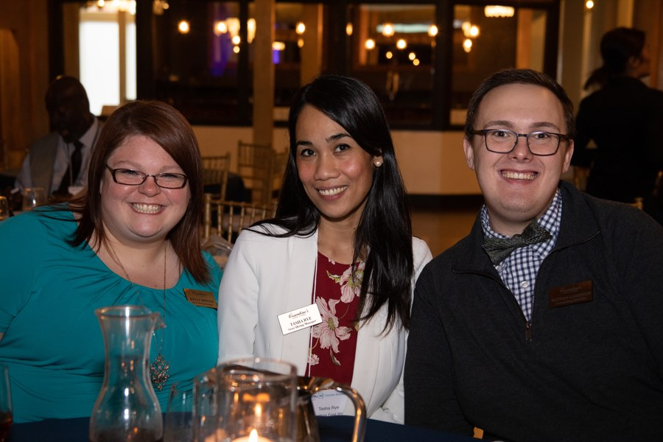

Partners in 2020
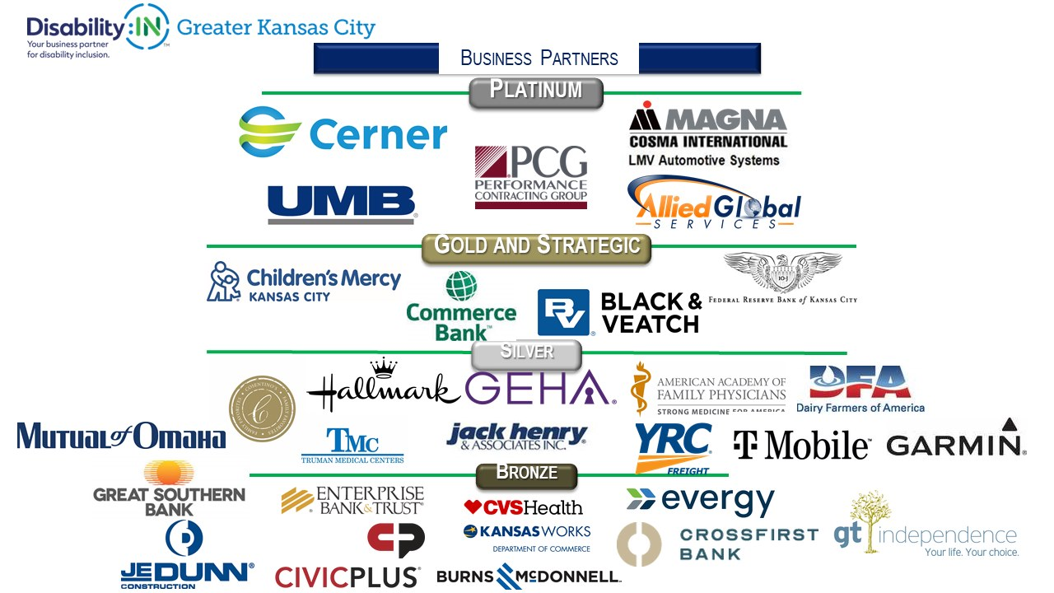
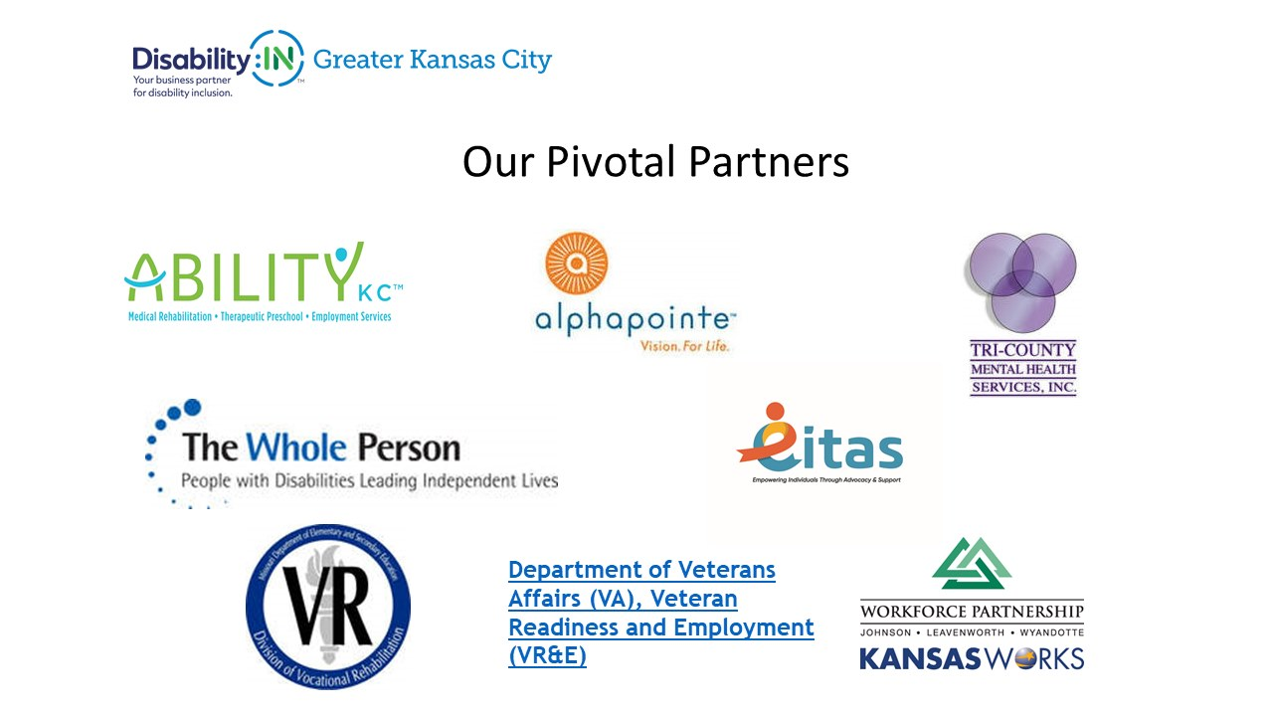
Signature Events:
- 6th Annual Disability Inclusion Summit - "Elevating Impact" featuring John Robinson
- Annual Thought Leaders Event - "Quieting the Whispers to Secure Disability Inclusion" featuring Dionne King
- 11th Annual Disability Champion Awards Event - Host & Emcee Derrick Nelson/Commerce Bank & featuring Dionne King with 2020 Champion Award Recipient Allied Global Services
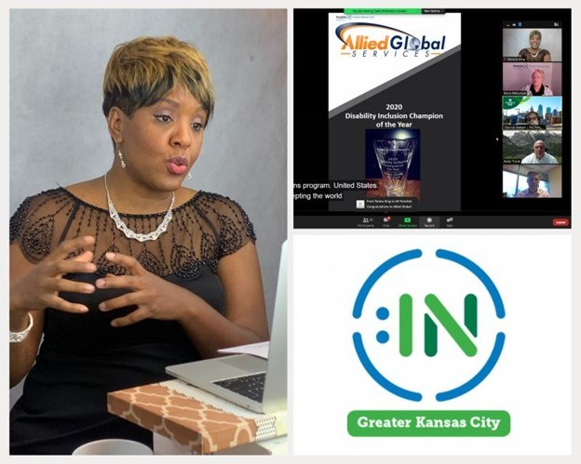
1 - Dionne King featured speaker at 11th Annual Disability Inclusion Champions Award Event.
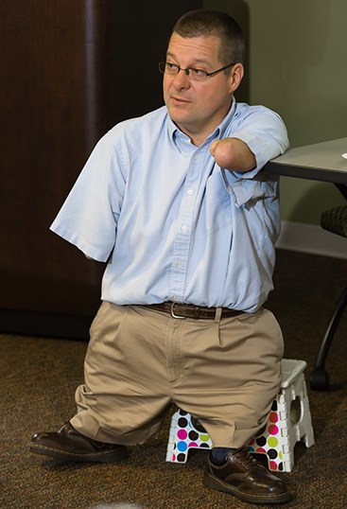
2 - John Robinson/CEO Our Ability
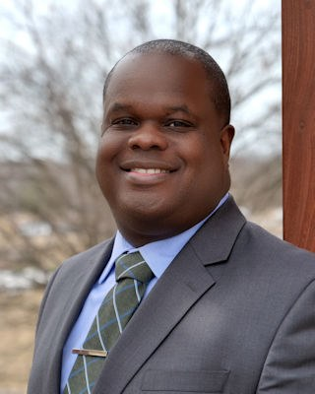
3 - Derrick Nelson/Commerce Bank
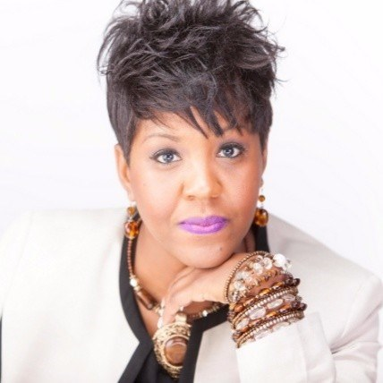
4 - Dionne King/DMK Consults
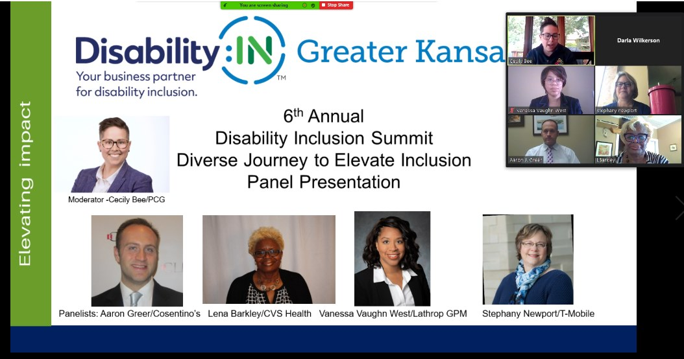
5 - Cecily Bee/PCG, Aaron Greer/Cosentino's Food Stores, Lena Barkley/CVS Health, Vanessa Vaughn West/Lathrop GPM, Stephany Newport/T-Mobile
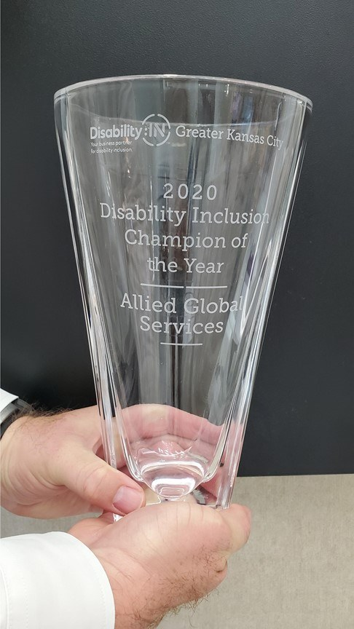
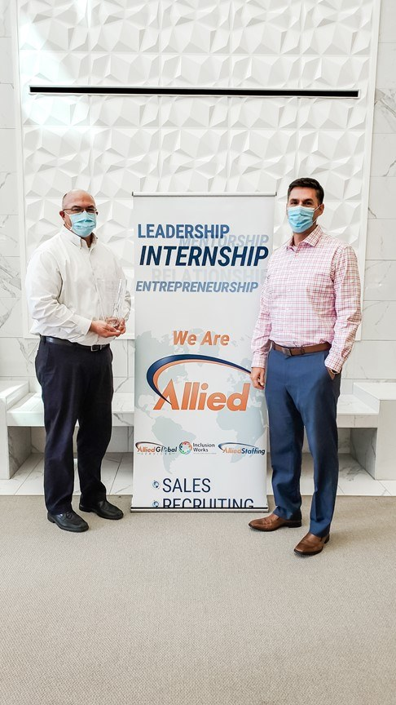
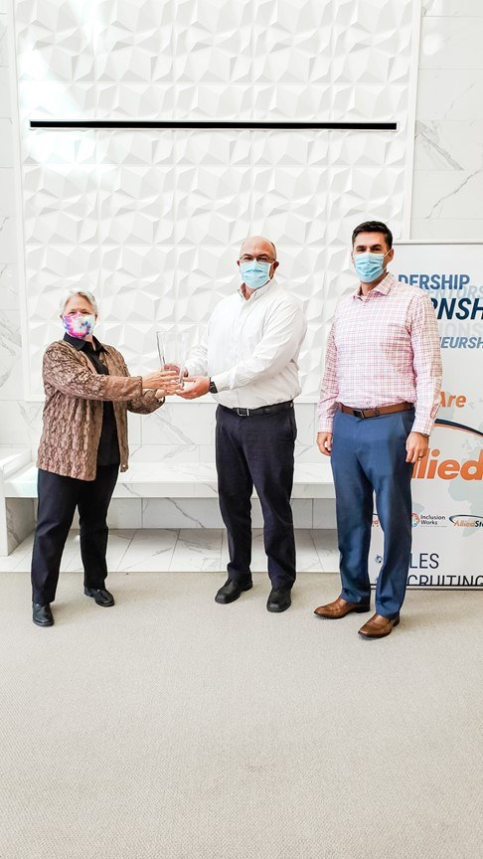
6 - Darla Wilkerson/Disability Inclusion of GKC, Andy Traub & Jason Trachsel/Allied Global Services
Partnering with Greater Kansas City Chamber
- D& I Workshop Series: Taking Action During COVID-19 Crisis to Hire and Retain People with Disabilities
- D&I Workshop Series: Demystifying the Hiring of People with Disabilities: Hiring and Retaining Qualified Talent
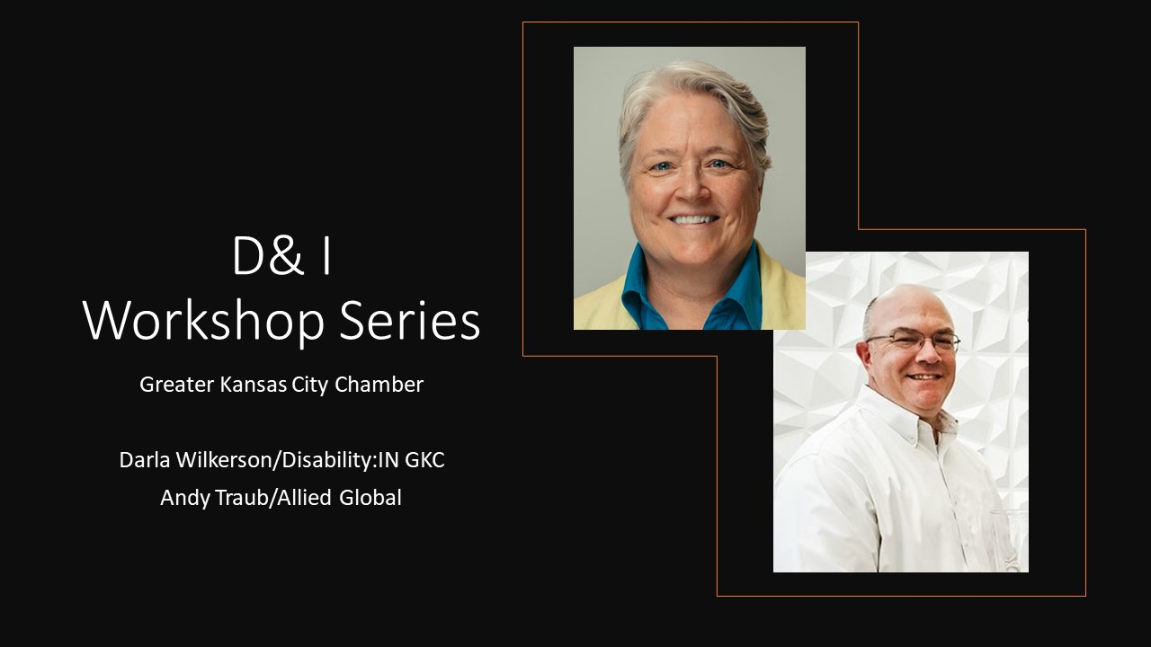

Strategic Partnerships
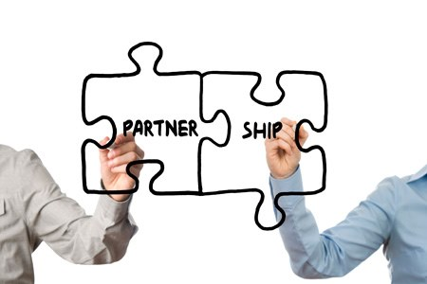

Getting Connected
- Our Ability Connect – hundreds of daily job postings and connecting business with candidates with disabilities. Free for candidates. Unlimited local postings included in select partnership benefits. Now offering monthly subscriptions for others. .
- Company Brand Impressions – 10,000 + opportunities for our partners' brands to be seen through marketing, website, social media, onsite events, etc.
- Pivotal Partners - community agencies are joining us in partnership to help elevate disability inclusion in Greater Kansas City. We encourage partnership with community agencies to connect with businesses who are employers of choice for people with disabilities.
- Kansas City's Disability Inclusion Network - Monthly meetings to connect business partners and community partners, sharing job openings and interested candidates.
- Grantham University - any partner of Disability:IN GKC has access to reduced tuition to over 60 degreed and certificate online programs. More info here.
- Partnerships with Disability:IN Chicagoland and Disability:IN Minnesota for discounted training events to any of our business and community partners.

