Center for Disability Inclusion Monthly News & Updates for September 2022

Upcoming CDI Programs

- August 16 at 9:00 am CST. Monthly Disability Inclusion Network meeting features CDI partners sharing their efforts, insights, challenges and successes. August presenters are The Whole Person and Kansas Work Dept of Commerce. Read more and register at https://www.centerfordisabilityinclusion.org/upcoming-events.html

- August 24 at 10:00 am CST - "Outreach and Recruitment Strategies to Build Your Pipeline". Presenter is Andy Traub, President and Founder, Traub & Associates Consulting is presenting. Read more and register at https://www.centerfordisabilityinclusion.org/webinars.html

Other Programs

- August 11 from 11:00 am to 1:00 pm Central. "Employee retention: creating an incusive and accessible workplace with successful career paths". US Bank presenting. Offered by Disability:IN Wisconsin. Read more and register at https://www.eventbrite.com/e/employee-retention-creating-an-inclusive-and-accessible-workplace-tickets-336486077917

- August 23 at 12:00 pm Central. “Creating an Accessible e-Commerce Experience” An accessible e-commerce experience expands your customer base and revenue. Read more and register at https://www.accessibility.com/event/2022/add-to-cart-creating-an-accessible-e-commerce-experience?utm_campaign=AccessibilityPlus2022&utm_medium=email&_hsmi=220399490&_hsenc=p2ANqtz--CC8Cw5IIsXyX6E7Z119PCE6Df2rMeQXZfuH7__gB9A9XDHRc1sQs6ikdEXhV-Iv_ncfbAJrVVy2U83z0lE9J30Yu793z33gwLPEL-07BBm1bm2GIF5Q_96B6jU0RELRQT-fKB&utm_content=220401778&utm_source=hs_email

- September 22 from 11:30 am to 1:00 pm Central. “Integrating Disability Owned Business Enterprises into Your Supply Chain”. Offered by Disability:IN Chicagoland, Disability:IN Wisconsin, Disability:IN Minnesota, Disability:IN DC Metro. Register at https://us02web.zoom.us/meeting/register/tZUqc-quqTIsG9ZaCiNz9cv7M4preG48vv-1

Annual Conference Coming Soon. Register Today!
- Join us for our 8th Annual Disability Inclusion Summit this Fall on September 14-15, 2022. Our virtual Annual Summit is one of the region's largest featuring national and regional experts on strategies and leading practices to advance disability inclusion in the workplace. Titled "Elevating Your Disability Inclusion Journey" it will be held September 14 from 10:00 am - 3:00 pm Central and September 15 from 12:30 - 4:30 pm Central.

- September 14 sessions focus on Charting Your Journey with:
  - BIG Announcement
  - Charting the Course
  - Getting Equipped
  - Building the Team
  - Elevating Your Hiring Practices

- September 15 sessions focus on Elevating Your Journey with:
  - Creating a Disability Focused ERG/BRG - Why Wait?
  - Elevating Enterprise-Wide Accessibility
  - The WHY to Disability Inclusion
  - Moving Forward

Full conference and single day tickets available. Learn more and register at https://www.centerfordisabilityinclusion.org/disability-inclusion-summit.html

Thank You to our Newest Partners – The Peregrine Hotel in Omaha and ACT Services

Thank You to our Renewing Partners:
- Garmin Interna
- Eitas
- Burns & McDonnell

GuideStar platinum seal of transparency.
We're pleased to announce the Center for Disability Inclusion ﻿has earned the GuideStar 2021 Platinum Seal of Transparency! ﻿Check out our https://www.guidestar.org/profile/26-4700449GuideStar profile at https://www.guidestar.org/profile/26-4700449

Connect with us today on Facebook at https://www.facebook.com/centerfordisabilityinclusion and LinkedIn at https://www.linkedin.com/company/centerfordisabilityinclusion

Interested in Partnership with CDI?
We offer a variety of Partnership Options for business and community agencies. Select the level of benefits, consultation, online job board and other services that best fits your organization's disability inclusion focus. Want to learn more? Let's schedule an exploratory conversation. View your partnership options at – https://www.centerfordisabilityinclusion.org/partnership.html or email Darla Wilkerson, CEO at dwilkerson@centerfordisabilityinclusion.org

Our 70 plus partners as of July 2022.
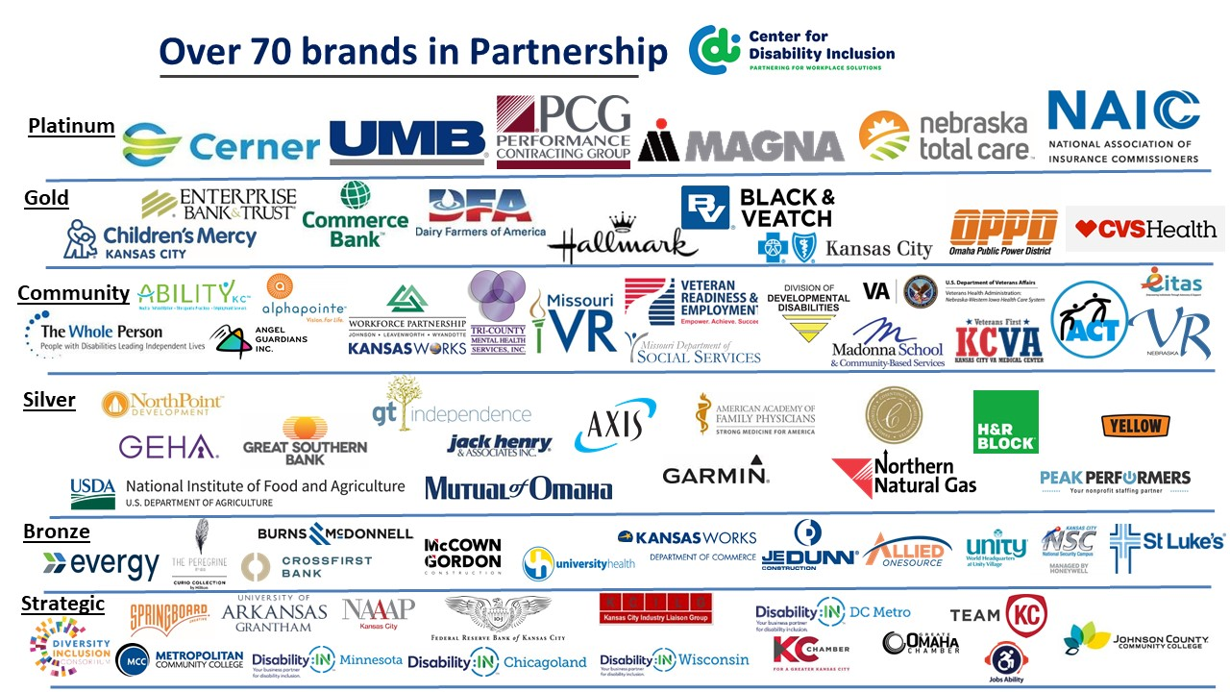

Visit the CDI website at - https://www.centerfordisabilityinclusion.org/

To unsubscribe from CDI emails, please email Brenda Perkins at bperkins@centerfordisabilityinclusion.org

