Center for Disability Inclusion News & Updates
for February, March and April 2023
Alt Text Word Version

Elevate Your Efforts with CDI’s new Seal of Accomplishment

Graphic of new seal for Leader in Disability Inclusion 2023 with watermark of SAMPLE overlayed at the bottom of text.
- New Seal of Accomplishment. February 1 Deadline to Get Started.

- This unique seal recognizes CDI business and organization partners across the country who are leaders and influencers in advancing disability inclusion.

- Recipients will have worked through the proprietary CDI Disability Inclusion Process from January through September 2023 and earned the right to leverage brand recognition by posting this seal throughout their organization's media. ​

- This Process provides a proven roadmap for businesses in the completion of milestones ​resulting in ​outcomes hat elevate disability inclusion ​in the workforce, workplace and marketplace.

- Must be a CDI Partner at Silver, Gold or Platinum by February 1, 2023 "Getting Started Deadline" for 2023 Award consideration.

- Learn more at https://www.centerfordisabilityinclusion.org/seal-of-accomplishment.html

CDI 2023 Programs
- January 17 - 9:00 am Central. Disability Inclusion Network Virtual Meeting spotlighting Glaucoma Awareness Month with CDI partners, Alphapointe and Missouri Rehabilitation Services for the Blind. Read more at https://www.centerfordisabilityinclusion.org/upcoming-events.html

- January 19 - 9:00 am Central. "Employee Resource Groups" Webinar with Cara Pelletier, Senior Director of Employee Experience at 15Five. Register by January 18. Read more at https://www.centerfordisabilityinclusion.org/learning--development-programs.html

- February 2 - 1:00 pm Central. "Innovating Disability Inclusion" Webinar with Jessica Lopez, disability advocate and full-time college student triple-majoring in Business, Economics and Communication. Register by February 1. Read more at https://www.centerfordisabilityinclusion.org/learning--development-programs.html

- February 21 - 9:00 am Central. Disability Inclusion Network Virtual meeting spotlighting Developmental Disability Awareness Month with CDI partner, Missouri Division of Developmental Disabilities. Read more at https://www.centerfordisabilityinclusion.org/upcoming-events.html

- February 22 – 9:30 am Central. Omaha Nebraska in-person Network Meeting hosted by CDI partner Mutual of Omaha. Panel discussion on “Developing a Disability ERG”. Read more at https://www.centerfordisabilityinclusion.org/upcoming-events.html

2022 Year I Review
What an exciting year for CDI with our national expansion and significant growth. Take a look at our metrics and impact at https://www.centerfordisabilityinclusion.org/2022-year-in-review.html

CDI Partnership Offers Tiered Options
CDI welcomes the opportunity to be include din your organization’s 2023 disability inclusion efforts.
You’ll be in good company with our 75+ partners Learn more about partnership options and associated benefits at https://www.centerfordisabilityinclusion.org/business-partners.html

2023 Calendar of Disability Awareness Related Dates
Throughout the year there are many opportunities to celebrate diversity. Discover the many occasions holidays, and 2023 Disability Awareness Related Dates across the US and globally at https://www.centerfordisabilityinclusion.org/resources.html

Thank You to our Renewing Partners:
- Hallmark Cards
- Dairy Farmers of America
- Allied OneSource
- NorthPoint Development

Year End Budgeting and CDI Partnership
- Are you working on your year end and 2023 budget?
- CDI would welcome the opportunity to be included in your DE&I efforts. To learn more about CDI partnership opportunities click here or contact Darla at dwilkerson@disabilityinclusion.org

Connect with us today on LinkedIn at https://www.linkedin.com/company/centerfordisabilityinclusion

Our 75 plus partners as of December 31, 2022.

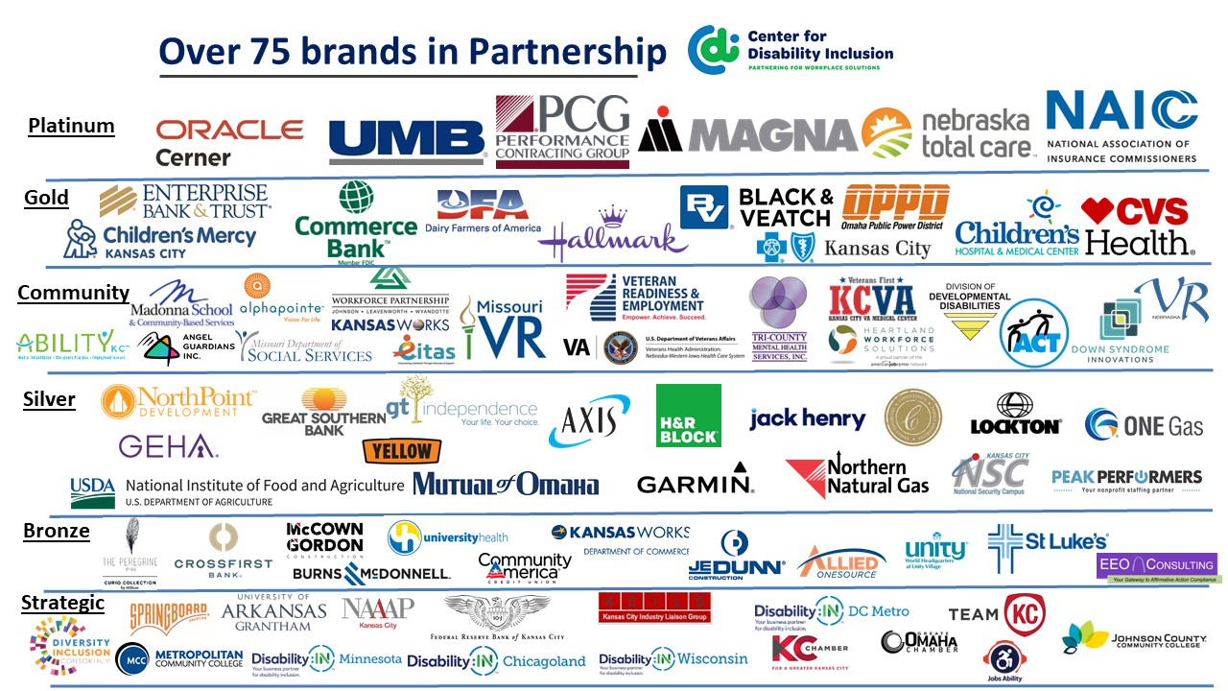

Visit the CDI website at - https://www.centerfordisabilityinclusion.org/

To unsubscribe from CDI emails, please email Brenda Perkins at bperkins@centerfordisabilityinclusion.org

