Center for Disability Inclusion Monthly News & Updates for June 2022

Expand your disability inclusion knowledge with Webinars and Learning Sessions.

- June 8 from 8:00 - 9:30 am CST. "A Trauma-Informed Approach to the Workplace: Best Practices for Supporting Employees Recovering from Trauma" Offered by Disability:IN Minnesota. Presenter:
Dr. Allison Battles, PhD, LP. Learn more and register at https://www.eventbrite.com/e/disabilityin-minnesotas-hybrid-june-member-event-tickets-335354703947

- June 14 from 11:00-12:00 pm CST. "Substance Abuse and Mental Health in the Workplace" Offered by Disability:IN Chicagoland. Presenter: Mark Sanders, LCSW, CADC with Great Lakes Addiction Technology Transfer Center (ATTC) Network. Learn more and register at https://www.centerfordisabilityinclusion.org/webinars.html

- In celebration of National Disability Independence Day and the 32nd anniversary of ADA signed into law. Join us on July 26 from 11:30-12:30 pm CST. "National Disability Independence Day, Celebrating the ADA – A Lived Experience by Joni Thomas". Presenter: Joni Thomas, Nebraska Total Care followed by facilitated discussion. Learn more and register at https://www.centerfordisabilityinclusion.org/webinars.html

Disability Inclusion Network meetings are 3rd Tuesday of month from 9:00 to 10:00 AM CST.
Features partner spotlights from two CDI partners sharing about their disability inclusion efforts, insights, challenges and successes. Free for CDI partners; prospective partners may attend two times
as a guest.

- June 21 – Black & Veatch and Enterprise Bank & Trust
- July 19 – Mutual of Omaha and Commerce Bank

Learn more and register at https://www.centerfordisabilityinclusion.org/upcoming-events.html

Connect with us today on Facebook at https://www.facebook.com/centerfordisabilityinclusion and LinkedIn at https://www.linkedin.com/company/centerfordisabilityinclusion

Join us for our 8th Annual Thought Leaders Forum on July 28 from 11:30 am – 12:30 pm CST. This year’s topic is titled "Leveraging Data to Drive Inclusion". Co-presenters are: Meg O'Connell, Founder and CEO of Global Disability Inclusion and Peter Rutigliano, Ph.D, Sr Principal and Data Analytics Leader with Mercer. Make plans to attend this virtual annual signature event and invite DE&I, HR and Compliance colleagues to learn about this leading topic. Learn more and register at https://www.centerfordisabilityinclusion.org/thought-leaders-forum.html

Join us for our 8th Annual Disability Inclusion Summit this Fall. Our virtual Annual Summit is one of the region's largest featuring national and regional experts on strategies and leading practices to advance disability inclusion in the workplace. Titled "Elevating Your Disability Inclusion Journey" this two day event will be September 14 from 10:00 am - 3:00 pm CST and September 15 from 12:00 - 4:30 pm CST. Full conference and single day tickets available. Learn more and register at https://www.centerfordisabilityinclusion.org/disability-inclusion-summit.html

Did You Know?
2022 Planning Resource is Available. The 2022 Calendar of Disability Awareness-Related Dates helps you stay up-to-date on important events and be proactive and intentional in your events planning, awareness and communications. June is "Awareness Month" for: Alzheimer's and Brain, PTSD, and Migraine & Headache, plus others. Check it out on our Resources page at https://www.centerfordisabilityinclusion.org/resources.html

Thank You to our Newest Partner – National Association of Insurance Commissioners (NAIC).
Thank You to our Renewing Partners.
- Blue Cross Blue Shield of Kansas City
- McCownGordon Construction
- University Health Kansas City
Did You Know?
- 2022 Planning Resource Available. The 2022 Calendar of Disability Awareness-Related Dates helps you stay up-to-date on important events and be proactive and intentional in your disability events planning. Check it out on our Resources page at https://www.centerfordisabilityinclusion.org/resources.html.

- Free workshop for Candidates with Disabilities. This session called, "Boost Your Job Search" Workshop is August 23 from 1:30 – 2:30 pm CST. Attendees receive guidance to maximize their online presence in Jobs Ability to accelerate their job search. Community agencies, colleges and universities - invite your clients and students with disabilities to register and participate at https://www.centerfordisabilityinclusion.org/boost-your-job-search-workshop---attend.html.

GuideStar platinum seal of transparency. We're pleased to announce the Center for Disability Inclusion ﻿has earned the GuideStar 2021 Platinum Seal of Transparency! ﻿Check out our GuideStar profile at https://www.guidestar.org/profile/26-4700449

Ready to Advance Your Disability Efforts?
CDI offers a variety of Partnership Options for business and community agencies. Select the level of benefits, consultation, online job board and other services that best fits your organization's disability inclusion focus. Want to learn more? Let's schedule an exploratory conversation. View your partnership options at – https://www.centerfordisabilityinclusion.org/partnership.html or email Darla Wilkerson, CEO at dwilkerson@centerfordisabilityinclusion.org

Our 70 plus partners in June 2022.
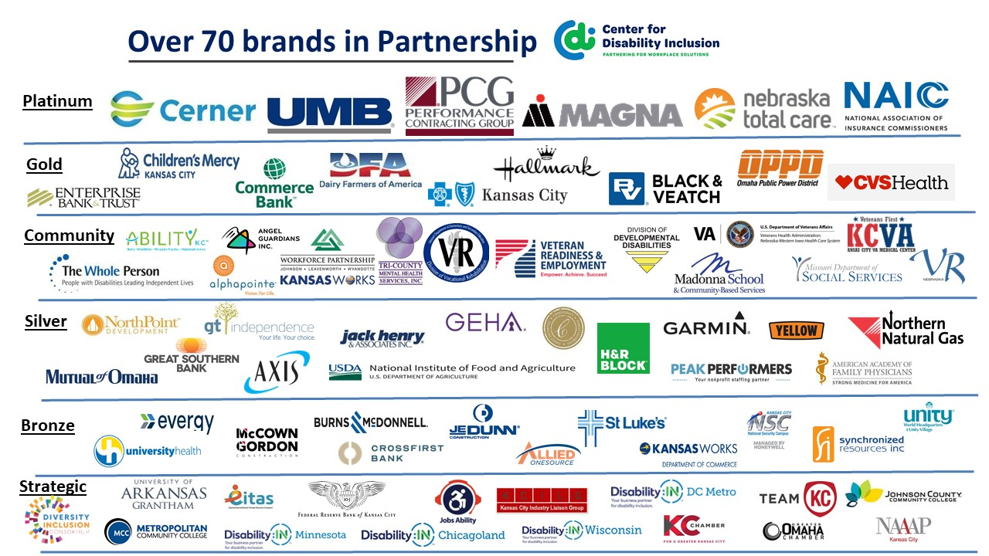

Visit the CDI website at - https://www.centerfordisabilityinclusion.org/

To unsubscribe from CDI emails, please email Brenda Perkins at bperkins@centerfordisabilityinclusion.org

