Center for Disability Inclusion News & Updates
for May, June and July 2023
Alt Text Word Version

CDI news and updates will now be sent quarterly instead of monthly. Stay informed and connected about events and announcements when you follow us on LinkedIn at https://www.linkedin.com/company/centerfordisabilityinclusion/

Disability Inclusion Network Meetings.
This unique peer to peer Network builds relationships through monthly learning and open conversations that elevate awareness and change, break down barriers, and improve the hiring process and workplace for people with disabilities.

- May 16 - 9:00 am Central - "Inclusive Recruitment & Hiring"
- June 20 – 9:00 am Central – “Career Development & Retention”
- June 28 – 9:30 am Central – Columbia Missouri in-person meeting
- July 18 – 9:00 am Central – “Accessibility & Accommodations”
- August 15 – 9:00 am Central – “Comp & Benefits”
- August 23 – 9:30 am Central – Omaha Nebraska in-person meeting
- Read more at https://www.centerfordisabilityinclusion.org/upcoming-events.html

Expand your disability inclusion knowledge.
- Elevate your knowledge and understanding of disability inclusion in the workplace when you attend our learning and development programs. View our 2023 Schedule at https://www.centerfordisabilityinclusion.org/learning--development-programs.html

- May 11 - "Revolutionizing Mental Health in the Workplace"
- May 23 - "Developing a Culture of Inclusivity"
- July 26 - "Foundations of the ADA and Workplace Inclusion"

Save the Date for 2023 Inclusion Summit with theme of Amplifying Intersectionality.
- September 28-29, 2003. Live in Kansas City Missouri at the Federal Reserve Bank plus virtual via zoom. Early bird registration through May 31 at https://www.centerfordisabilityinclusion.org/attendees.html
- This collaborative national 2023 Inclusion Summit is led by the Center for Disability Inclusion in partnership with the DEI Consortium (KC), KC Chamber and NAAAP-KC (National Association of Asian American Professionals-Kansas City), centered around inclusion for all. Mark your calendar! read more at https://www.centerfordisabilityinclusion.org/inclusion-summit-2023.html
- The Inclusion Summit will present national keynote speakers who will challenge our thinking and regional subject matter experts sharing - and read more at https://www.centerfordisabilityinclusion.org/schedule.html

- Corporate Sponsorships available to expand your company’s brand visibility to this audience. To explore how your organization can support financially or in-kind, this collaborative national summit, contact Darla Wilkerson at dwilkerson@centerfordisabilityinclusion and read more at https://www.centerfordisabilityinclusion.org/sponsors.html

Elevate Your Efforts with CDI’s new Seal of Accomplishment.
Graphic of new seal for Leader in Disability Inclusion 2023 with watermark of SAMPLE overlayed at the bottom of text.
- This unique Seal of Accomplishment recognizes CDI business partners across the US who are leaders and influencers in advancing disability inclusion. This proprietary process provides a customized roadmap for each partner to advance their efforts by focusing on intentional progress.
- Recipient companies will have worked through the proprietary Disability Inclusion Process, designed by CDI, and submitted an application in 4th quarter demonstrating work done and progress made during the year. Awards Event December 1, 2023.
- Want to learn more and consider including the Seal in your 2024 efforts?
- Learn more at https://www.centerfordisabilityinclusion.org/seal-of-accomplishment.html

Resources to support your efforts.
Disability related events to acknowledge and celebrate in your organization.

- May - Mental Health Awareness Month and May 18 is Global Accessibility Awareness Day.
- June - PTSD, Alzheimer's and Brain Awareness Month and June 5 is National Cancer Survivor's Day.
- July - Disability Pride Month and July 26 is the 33rd Anniversary of the Americans with Disabilities Act.
- Learn more on our Resources page at https://www.centerfordisabilityinclusion.org/resources.html

CDI Board welcomes new directors.
The CDI Board of Directors includes 14 business leaders from across the US. Welcome to our newest members.
- Tracy Dickens, Director of Recruiting, Americas at Black & Veatch, and
- Veronica Villalobos, Vice President of DEI Strategy at Allegheny Health Network.

CDI Partnership Offers Tiered Options
CDI offers a variety of services to help organizations advance their efforts:
- Virtual and onsite Training on a variety of disability inclusion topics
- Fee-based Consultation around specific disability inclusion needs
- Tiered Partnership options for business and community agencies

You’ll be in good company with our 80+ partners. Learn more about partnership options and associated benefits at https://www.centerfordisabilityinclusion.org/business-partners.html

Thank You to our Newest Partners:
- Ameristar Casino
- Labcorp
- Magna Electric Vehicle Structures
- The Transition Academy
- The University of Kansas

Thank You to our Renewing Partners:
- Blue Cross Blue Shield of Kansas City
- Commerce Bank & Trust
- Enterprise Bank & Trust
- Federal Bank of Kansas City
- Jack Henry
- JE Dunn Construction
- McCownGordon Construction
- St Lukes Health System (Idaho)
- University Health
- Yellow

Connect with us today on LinkedIn at https://www.linkedin.com/company/centerfordisabilityinclusion

Our 80 plus partners as of April 30, 2023.

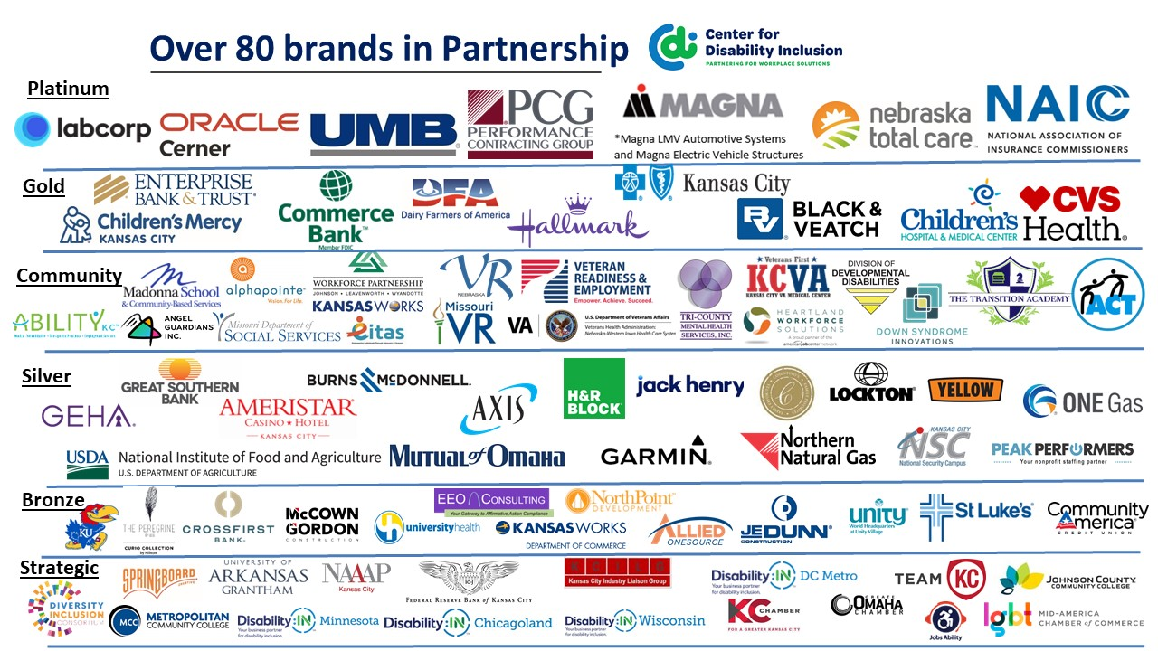

Visit the CDI website at - https://www.centerfordisabilityinclusion.org/

To unsubscribe from CDI emails, please email Brenda Perkins at bperkins@centerfordisabilityinclusion.org

