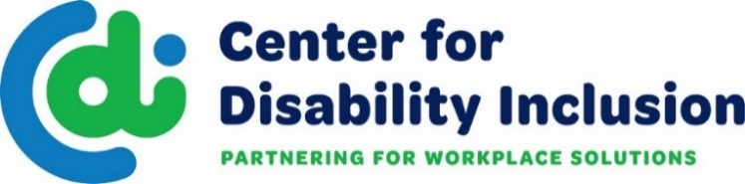

CDI is a national organization that partners with businesses
to advance their disability inclusion efforts.

What We Do

- We provide consultation and training through our proprietary Disability Inclusion Process™ that helps businesses create a road map for inclusive practices and work towards
achievement of our annual “Leader in Disability Inclusion Seal of Accomplishment”.
- We deliver educational events and network opportunities that expand the
possibilities for disability inclusion.
- We create collaborative relationships with the business community and key
stakeholders including business leaders, HR/DEI professionals and service organizations.
- We provide information and resources that drive talent acquisition, employee resource groups, diversity supply chain and disability inclusion.
- We provide avenues for connecting to talent with disabilities.
- We support federal contractors and subcontractors in meeting Section 503 regulations.

Tiered Approach to Business Partnership

Platinum Level = Top Tier includes 12 hours of consultation, training, associated benefits
Gold Level = 8 hours of consultation, training, associated benefits
Silver Level = 4 hours of consultation, training, associated benefits

- Tiered partnerships provide corporate partners with a deeper dive into the disability inclusion process, help them gain traction and create a road map for targeted disability inclusion efforts.
- We meet you wherever you are on your journey and are ready to work together to help you elevate disability inclusion in your workplace and marketplace.
- Doing this work can lead to receiving CDI’s national seal of accomplishment for being a
Leader in Disability Inclusion. Contact us for eligibility criteria.
- Partners are eligible to work toward the “Leader in Disability Inclusion Seal of Accomplishment”

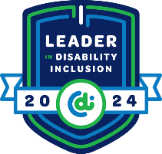
Sample Seal
SAMPLE
Visit our website for more details - www.centerfordisabilityinclusion.org

Center for Disability Inclusion
Business Partner Options and Associated Benefits
Partnership Level | Platinum | Gold | Silver | Bronze
Consultation & Training | Strategic Plan Design Assistance  - Comprehensive plan development using a benchmarking tool to create a profile, plus Consultation/Training - up to 12 hours | Up to 8 hours | Up to 4 hours | X
 | Eligible for receiving consultation in the CDI Disability Inclusion Process™  to work toward achieving the annual Leader in Disability Inclusion Seal of Accomplishment |  |  | X
Job Connection | Online job platform for companies to expand their talent pipeline and reach candidates with disabilities. Nationwide unlimited reach utilizing your careers page. |  |  | X
Signature Events | 4 Registrations + discounted registration fees for additional attendees  - Inclusion Summit – annual conference  - Annual Award Event – annual recognition award for the Leader in Disability Inclusion Seal of Accomplishment | 3  registrations | 2  registrations | 1  registration
Educational Programs | 4 Registrations + discounted registration fees for additional attendees  - Webinars – Subject Matter Experts on disability inclusion topics  - Disability Inclusion Network – monthly meetings to connect business and community partners to enhance outreach and recruitment efforts and strengthen relationships. | 3  registrations | 2  registrations | 1  registration
Brand Recognition | Company Logo Promotions  - Prominent homepage and partner page of website  - Prominent promotions on printed materials  - Prominent promotions on social media sites | Company logo on home & partner pages, printed materials, social media sites | Company logo on partner page, printed materials | Company logo on partner page
Annual Investment | $8,000 | $5,500 | $4,000 | $2,000
Added Value | Discounted Partner Benefits  - Disability:IN Chicagoland, Minnesota, Wisconsin and DC Metro events
Ask Us How to Get Started Today:
Meaghan Walls, CEO mwalls@centerfordisabilityinclusion.org, Brenda Perkins, Director of Business Relations bperkins@centerfordisabilityinclusion.org,
Andy Traub, Director of Corporate Disability Inclusion atraub@centerfordisabilityinclusion.org

