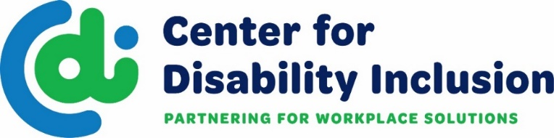
CDI is a national organization that partners with businesses
to advance their disability inclusion efforts.
What We Do

- We provide consultation through a disability inclusion process that helps businesses
create a road map for inclusive practices and achieve an annual seal in “Leader in
Disability Inclusion”.
- We deliver educational events and network opportunities that expand the
possibilities for disability inclusion.
- We create collaborative relationships with the business community and key
stakeholders including business leaders, HR/DEI professionals and service organizations.
- We provide information and resources that drive talent acquisition, diversity supply
chain and disability inclusion.
- We provide avenues for connecting to talent with disabilities.
- We support federal contractors and subcontractors in meeting Section 503 regulations.
Tiered Approach to Business Partnership

Platinum Level = Top Tier includes 16 hours of consultation and associated benefits
Gold Level = 8 hours of consultation and associated benefits
Silver Level = 4 hours of consultation and associated benefits
- Tiered partnerships provide corporate partners with a deeper dive into the disability inclusion process, help them gain traction and create a road map for targeted disability inclusion efforts.
- We meet you wherever you are on your journey and are ready to work together to help you elevate disability inclusion in your workplace and marketplace.
- Doing this work can lead to receiving CDI’s national seal of accomplishment for being a
Leader in Disability Inclusion. Contact us for eligibility criteria.
- Partners are eligible for CDI’s “Leader in Disability Inclusion” Seal of Accomplishment.
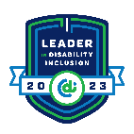
Sample Seal
SAMPLE
Visit our website for more details - www.centerfordisabilityinclusion.org

Center for Disability Inclusion
Business Partner Options and Associated Benefits
Partnership Level | Platinum | Gold | Silver | Bronze
Consultation & Training | Strategic Plan Design Assistance  - Comprehensive plan development using a benchmarking tool to create a profile, plus Consultation - up to 16 hours of onsite or virtual per year.  - Training - one virtual or onsite program per year; choose from variety of available disability inclusion topics | Up to 8 hours | Up to 4 hours | X
Jobs Ability | Online job board for companies to expand their talent pipeline and reach candidates with disabilities, unlimited local postings. Nationwide unlimited postings available for an additional $8,000 annually. (or $1,000 per individual market) | Unlimited  local postings | Unlimited local postings | X
Signature Events | 4 Registrations + discounted registration fees for additional attendees  - Disability Inclusion Summit – annual conference  - Champions Award Event – annual recognition award | 3  registrations | 2  registrations | 1 registration
Educational Programs | 4 Registrations + discounted registration fees for additional attendees  - Webinars – Subject Matter Experts on disability inclusion topics  - Disability Inclusion Network – monthly meetings to connect business and community partners to enhance outreach and recruitment efforts and strengthen relationships. | 3  registrations | 2  registrations | 1  registration
Brand Recognition | Company Logo Promotions  - Prominent homepage and partner page of website  - Prominent promotions on printed materials  - Prominent promotions on social media sites  - Average 22,000+ brand impressions | Company logo on home & partner pages, social media sites.  Avg 17,000+ impressions | Company logo on partner page, printed materials.  Avg 5,000+ impressions | Company logo on partner page.  Avg 2,000+ impressions
Annual Investment | $8,000 | $5,500 | $4,000 | $2,000
Added Value | Discounted Partner Benefits  - Disability:IN Chicagoland, Minnesota, Wisconsin, DC Metro events  - Discounted Tuition at Arkansas Grantham University for all employees of our Partner companies

Ask Us How to Get Started Today: Darla Wilkerson/CEO dwilkerson@centerfordisabilityinclusion.org,
Brenda Perkins/Director of Business Relations bperkins@centerfordisabilityinclusion.org, Meaghan Walls/Director of Business Relations-NE mwalls@centerfordisabilityinclusion.org, Andy Traub/Director of Corporate Disability Inclusion atraub@centerfordisabilityinclusion.org

