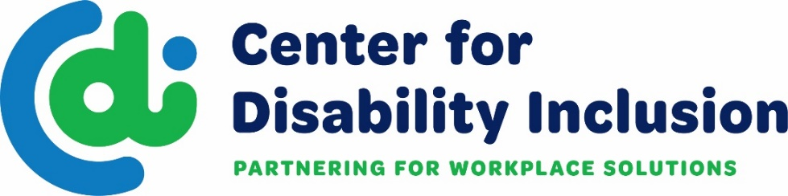  CDI is a national organization that partners with businesses  to advance their disability inclusion efforts.  What We Do  - We deliver educational events and networks that expand the possibilities for disability inclusion.  - We create collaborative relationships with the business  community and key stakeholders including business leaders,  HR professionals and service organizations.  - We provide information and resources that drive talent acquisition, diversity supply chain and disability inclusion.  - We provide consultation and training to enhance awareness  and skills in disability inclusion.  - We connect business partners at any stage of disability inclusion with thought leadership and solutions.  - We provide avenues for connecting to talent with disabilities.  The Center for Disability Inclusion advances disability inclusion by providing the business community with tools, resources and solutions that drive employee hiring, engagement and performance. |  | 2022  Services  Annual Disability Inclusion Summit  Disability Champion Awards Event  Thought Leaders Event  Special Topic Programs  Consultation  Customized Training  Jobs Ability – online job board  Center for Disability Inclusion  PO Box 901296 Kansas City, MO 64190  www.centerfordisabilityinclusion.org  816.284-3224
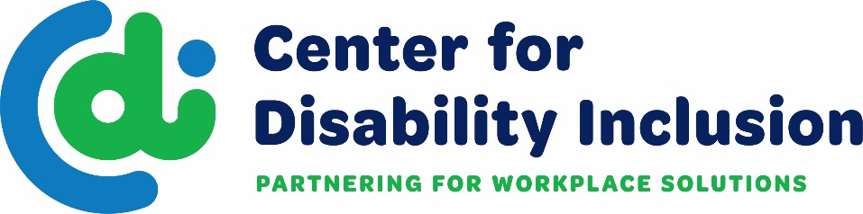
The Center for Disability Inclusion has a tiered approach to partnership. Our top-level Platinum partnership provides a deeper dive into the disability inclusion process and helps our corporate partners gain traction and create a road map for targeted disability inclusion efforts. We meet you where you are on your journey and are ready to work together to help you elevate
disability inclusion in your workplace and marketplace.

Platinum Partnership
($8,000 annual investment)
Customized Consultation
- Assistance in designing a disability inclusion strategic plan.
  - A comprehensive disability inclusion plan can be developed using
a benchmarking tool that can assist in preparing the design for disability
inclusion strategies.
  - Up to 16 hours of consultation – Partners receive onsite and virtual consultation and technical assistance based on their identified needs. Can include: 503 regulatory requirements, how to build a talent pipeline of candidates with disabilities, effective accommodation policies, processes and practices, self-identification strategies, web accessibility, ERG/BRG/Affinity Groups, training for hiring managers and more.
CDI

Additional Benefits for Platinum Partners
- Brand Recognition
  - Prominent logo placement on our website, print and digital communications.
- Jobs Ability
  - Online job board designed for candidates with disabilities and companies who need to expand their talent pipeline.
  - Unlimited job postings
- Disability Inclusion Network
  - 2 attendees at each 60-minute monthly meeting with business and pivotal partners (community agencies).
  - Develop meaningful partnerships, address barriers to disability inclusion and employment, make significant connections that result in jobs being filled.
- Disability Inclusion Summit
  - 4 complimentary registrations to this annual event
  - Annual Summit - information packed Conference
- Champions Awards Event
  - 4 complimentary registrations to this annual event
  - Recognition of companies leading in their disability inclusion efforts.
- Thought Leaders Event
  - 2 complimentary registrations to this annual event
  - Subject matter expert presentation and facilitation of inclusion best practices
- Educational Programs
  - 4 complimentary registrations to each program/webinar
  - Relevant just in time training events
See Partnership information on next page for more details.
Ask us how to get started today.
Contact Darla Wilkerson/CEO | dwilkerson@centerfordisabilityinclusion.org
Brenda Perkins/Director of Business Relations
bperkins@centerfordisabilityinclusion.org
Meaghan Walls/Director of Business Relations Nebraska mwalls@centerfordisabilityinclusion.org
Visit our website for more details - www.centerfordisabilityinclusion.org

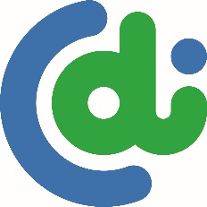

Center for Disability Inclusion
Business Partner Options and Associated Benefits
Partnership Level | Platinum | Gold | Silver | Bronze
Consultation & Training | Strategic Plan Design Assistance  - Comprehensive plan development using a benchmarking tool to create a profile, plus Consultation - up to 16 hours of onsite or virtual per year.  - Training - one virtual or onsite program per year; choose from variety of available disability inclusion topics | Up to 8 hours | Up to 4 hours | X
Jobs Ability | Online job board for companies to expand their talent pipeline and reach candidates with disabilities, unlimited local postings. | Unlimited  local postings | Unlimited local postings | X
Signature Events | 4 Registrations + discounted registration fees for additional attendees  - Disability Inclusion Summit – annual conference  - Champions Award Event – annual recognition award  - Thought Leaders Event – annual leadership forum | 3  registrations | 2  registrations | 1 registration
Educational Programs | 4 Registrations + discounted registration fees for additional attendees  - Webinars – Subject Matter Experts on disability inclusion topics  - Disability Inclusion Network – monthly meetings to connect business and community partners to enhance outreach and recruitment efforts and strengthen relationships. | 3  registrations | 2  registrations | 1  registration
Brand Recognition | Company Logo Promotions  - Prominent homepage and partner page of website  - Prominent promotions on printed materials  - Prominent promotions on social media sites  - Average 22,000+ brand impressions | Company logo on home & partner pages, social media sites.  Avg 17,000+ impressions | Company logo on partner page, printed materials.  Avg 5,000+ impressions | Company logo on partner page.  Avg 2,000+ impressions
Annual Investment | $8,000 | $5,500 | $4,000 | $2,000
Added Value | Discounted Partner Benefits  - Disability:IN Chicagoland, Minnesota, Wisconsin, DC Metro events  - Discounted Tuition at Grantham University for all employees of our Partner companies

Many community agencies are joining us in partnership as well. Learn more by contacting Darla Wilkerson/CEO dwilkerson@centerfordisabilityinclusion.org

