Center for Disability Inclusion Monthly News & Updates for January 2023
Alt Text Word Version

Elevate Your Efforts with new CDI Seal of Accomplishment

Graphic of new seal with watermark of SAMPLE overlayed at the bottom of text – Leader in Disability Inclusion 2023

​
New Seal of Accomplishment. February 1 Deadline to Get Started.

This unique seal recognizes CDI business and organization partners across the country who are leaders and influencers in advancing disability inclusion.

Recipients will have worked through the proprietary CDI Disability Inclusion Process from January through September 2023 and earned the right to leverage brand recognition by posting this seal throughout their organization's media. ​

This Process provides a proven roadmap for businesses in the completion of milestones ​resulting in ​outcomes hat elevate disability inclusion ​in the workforce, workplace and marketplace.

Must be a CDI Partner at Silver, Gold or Platinum by February 1, 2023 "Getting Started Deadline" for 2023 Award consideration.

Learn more at https://www.centerfordisabilityinclusion.org/seal-of-accomplishment.html

CDI 2023 Programs

- January 17 - 9:00 am Central. Disability Inclusion Network Virtual Meeting spotlighting Glaucoma Awareness Month with CDI partners, Alphapointe and Missouri Rehabilitation Services for the Blind. Read more at https://www.centerfordisabilityinclusion.org/upcoming-events.html

- January 19 - 9:00 am Central. "Employee Resource Groups" Webinar with Cara Pelletier, Senior Director of Employee Experience at 15Five. Register by January 18. Read more at https://www.centerfordisabilityinclusion.org/learning--development-programs.html

- February 2 - 1:00 pm Central "Innovating Disability Inclusion" Webinar with Jessica Lopez, disability advocate and full-time college student triple-majoring in Business, Economics and Communication. Register by February 1. Read more at https://www.centerfordisabilityinclusion.org/learning--development-programs.html

- February 21 - 9:00 am Central Disability Inclusion Network Virtual meeting spotlighting Developmental Disability Awareness Month with CDI partner, Missouri Division of Developmental Disabilities. Read more at https://www.centerfordisabilityinclusion.org/upcoming-events.html

Did You Miss CDI's #GivingTuesday?
There's still time to make a donation of any amount before year end. Help us promote Jobs Ability, our online job board that connects candidates with disabilities to businesses who are looking for amazing talent. You can give at https://www.centerfordisabilityinclusion.org/business-partners.html

Expand Your Talent Pipeline
Our strategic partner, Jobs Ability is an international Premier Artificial Intelligence-driven system that matches people with disabilities' skills to jobs. The system includes Ableist Language Detector (Abli.AI) to filter job descriptions, make proper language recommendations and help companies adhere to Section 508 with web and digital accessibility.

This resource is included in CDI partnerships at Silver, Gold, Platinum and Pivotal Tier 3. Learn more at https://www.centerfordisabilityinclusion.org/employers.html

Since January 2020, Our Ability sites have delivered 12,337 "Apply" click-throughs to our corporate partners.

October 2022 Stats:
- 8,916 - JobsAbility.com visitors
- 2,800+ - Jobs Ability completed profiles
- 95+ - Employers
- 93,546 - Job postings
- 2,039 - OurAbility.Jobs visitors
- 383 - OurAbility.Jobs Apply clicks

Thank You to our Newest Partners:
- Community America Credit Union
- Lockton

Thank You to our Renewing Partners:
- Angel Guardians, Inc.
- GEHA
- Peak Performers
- Children’s Mercy Kansas City

Year End Budgeting and CDI Partnership
- Are you working on your year end and 2023 budget?
- CDI would welcome the opportunity to be included in your DE&I efforts. To learn more about CDI partnership opportunities click here or contact Darla at dwilkerson@disabilityinclusion.org

Connect with us today on Facebook at https://www.facebook.com/centerfordisabilityinclusion and LinkedIn at https://www.linkedin.com/company/centerfordisabilityinclusion

Our 75 plus partners as of November 30, 2022.

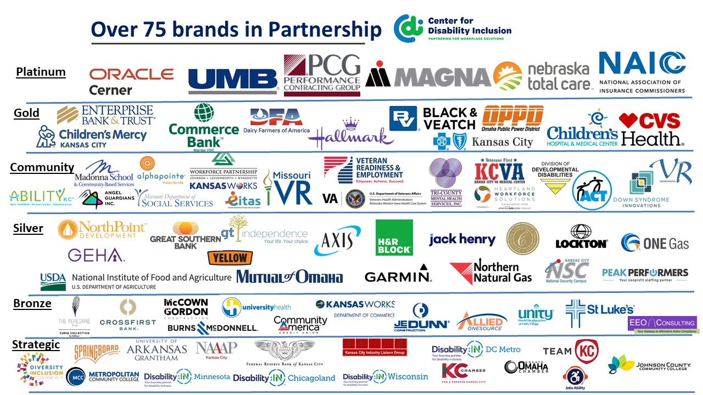

Visit the CDI website at - https://www.centerfordisabilityinclusion.org/

To unsubscribe from CDI emails, please email Brenda Perkins at bperkins@centerfordisabilityinclusion.org

