Center for Disability Inclusion Monthly News & Updates for July 2022

Programs This Month

- July 19 at 9:00 am CST. Disability Inclusion Network meeting features CDI partners sharing their efforts, insights, challenges and successes. July presenters are Mutual of Omaha and Commerce Bank. Read more and register at https://www.centerfordisabilityinclusion.org/upcoming-events.html

- July 26 at 11:30 am CST - "National Disability Independence Day, Celebrating the ADA – A Lived Experience by Joni Thomas" celebrates the 32nd signing of the ADA. Presenter: Joni Thomas, Nebraska Total Care followed by facilitated discussion. Learn more and register at https://www.centerfordisabilityinclusion.org/webinars.html

Programs Next Month

- August 16 at 9:00 am CST. Monthly Disability Inclusion Network meeting features CDI partners sharing their efforts, insights, challenges and successes. August presenters are The Whole Person and Kansas Work Dept of Commerce. Read more and register at https://www.centerfordisabilityinclusion.org/upcoming-events.html

- August 24 at 10:00 am CST - "Outreach and Recruitment Strategies to Build Your Pipeline". Presenter is Andy Traub, President and Founder, Traub & Associates Consulting is presenting. Read more and register at https://www.centerfordisabilityinclusion.org/webinars.html

Annual Signature Events

- July 28 at 1:00 pm CST – “Leveraging Data to Drive Inclusion”. Co-presenters: Meg O'Connell, Founder and CEO of Global Disability Inclusion and Peter Rutigliano, Ph.D., Sr Principal and Data Analytics Leader, with Mercer. Today, we use data for almost every decision we make, whether it is looking at the weather forecast, sales revenues, projecting expenses, analyzing customer trends and employee engagement. Tickets included in your Partner benefits. Read more and register at https://www.centerfordisabilityinclusion.org/thought-leaders-forum.html

- Join us for our 8th Annual Disability Inclusion Summit this Fall on September 14-15, 2022. Our virtual Annual Summit is one of the region's largest featuring national and regional experts on strategies and leading practices to advance disability inclusion in the workplace. Titled "Elevating Your Disability Inclusion Journey" it will be held September 14 from 10:00 am - 3:00 pm CST and September 15 from 12:00 - 4:30 pm CST. Full conference and single day tickets available. Learn more and register at https://www.centerfordisabilityinclusion.org/disability-inclusion-summit.html

Quote from CDI partner Jay Bohanon (he/they), Diversity, Inclusion & Culture Consultant, GEHA:
"You shouldn’t have to ask for accommodations, they should just exist. We should live in a world where anybody with ANY BODY can go into a room building, space, or even job and succeed because everything they need is already there."

In the News
Congratulations to the KC Chamber’s Champions of Diversity and ACE Award winners. All are Center for Disability Inclusion partners and will be honored at the 2022 POWER of Diversity Celebration on July 20 in Kansas City for their efforts in advancing diversity and inclusion. Award recipients are:
- Commerce Bank - Champion of Diversity
- GEHA - Non-profit Champion of Diversity
Our CEO, Darla Wilkerson, recipient of the 2021 Ace Award will present one of the Ace awards. Ace Award winners are:
- JE Dunn Construction - Drew Eanes
- Blue Cross and Blue Shield of Kansas City - Emanuel McCrainey
- Children's Mercy Hospital - Tiffany Willis

New Resource

The Diversity & Inclusion Consortium recently hosted an event with author Farzana Nayani to launch her new book, "The Power of Employee Resource Groups". This will be an excellent addition to your toolbox. Learn more at https://www.amazon.com/Power-Employee-Resource-Groups-Authentic/dp/1523001240

Thank You to our Newest Partner – Springboard
Thank You to our Renewing Partners:
- LMV Magna
- Cerner
- Great Southern Bank
- Axis Capital
- H&R Block

GuideStar platinum seal of transparency.
We're pleased to announce the Center for Disability Inclusion ﻿has earned the GuideStar 2021 Platinum Seal of Transparency! ﻿Check out our https://www.guidestar.org/profile/26-4700449GuideStar profile at https://www.guidestar.org/profile/26-4700449

Connect with us today on Facebook at https://www.facebook.com/centerfordisabilityinclusion and LinkedIn at https://www.linkedin.com/company/centerfordisabilityinclusion

Interested in Partnership with CDI?
We offer a variety of Partnership Options for business and community agencies. Select the level of benefits, consultation, online job board and other services that best fits your organization's disability inclusion focus. Want to learn more? Let's schedule an exploratory conversation. View your partnership options at – https://www.centerfordisabilityinclusion.org/partnership.html or email Darla Wilkerson, CEO at dwilkerson@centerfordisabilityinclusion.org

Our 70 plus partners in June 2022.
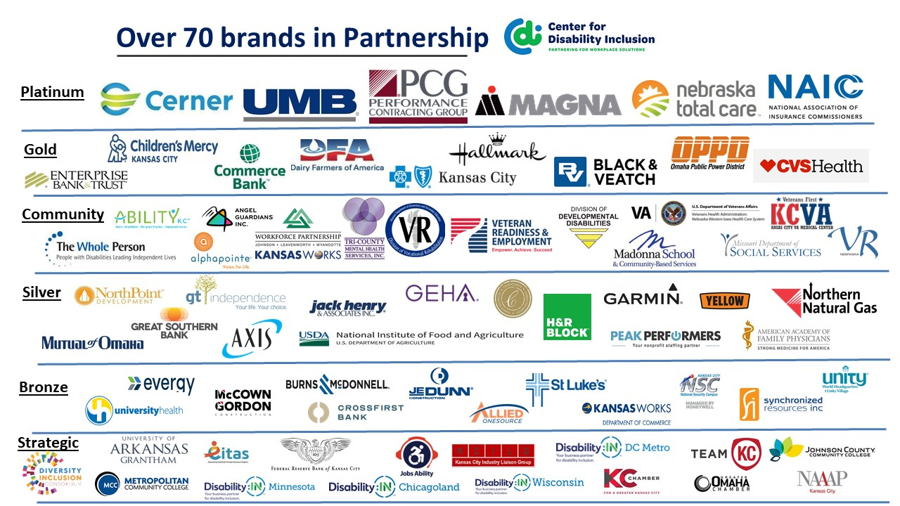

Visit the CDI website at - https://www.centerfordisabilityinclusion.org/

To unsubscribe from CDI emails, please email Brenda Perkins at bperkins@centerfordisabilityinclusion.org

