Center for Disability Inclusion Monthly News & Updates for May 2022

Expand your disability inclusion knowledge with Webinars and Learning Sessions in celebration of Global Accessibility Awareness Day.
- May 19 from 11:30 am - 12:30 pm CST. "Assistive Technology & Accommodations: Simpler Than You Think". Presenters: Meaghan Walls, President/CEO of Assistology, LLC and Chris Miller, Director of Employment Services, Madonna School & Community-Based Services. Learn more and register at https://www.centerfordisabilityinclusion.org/webinars.html

- May 19 from 1:00-2:00 pm CST. "A Conversation on Disability Accessibility in the Workplace & Marketplace". This webinar is offered by Disability:IN Chicagoland, in partnership with Northern Trust. Learn more and register at https://www.eventbrite.com/e/a-conversation-on-digital-accessibility-in-the-workplace-and-marketplace-tickets-305001506717

- May 12 from 9:00-11:00 am CST. "Framework for Building a Disability Inclusive Organization". This webinar is offered by Disability:IN Wisconsin. Keynote presenter: Wendy Strobel Gower, Director of Disability-Inclusive Workplaces and Employer Initiatives at Cornell University, plus two other presenters. No cost event. Learn more and register at https://disabilityinwisconsin.org/event/building-your-business-inclusion-roadmap/

Disability Inclusion Network meetings are 3rd Tuesday of month from 9:00 to 10:00 AM CST.
Features partner spotlights from two CDI partners sharing about their disability inclusion efforts, insights, challenges and successes. Free for CDI partners; prospective partners may attend two times
as a guest.

- May 17 - GEHA and Kansas City VA Medical Center
- June 21 – Black & Veatch and Enterprise Bank & Trust
- July 19 – Mutual of Omaha and Commerce Bank

Learn more and register at https://www.centerfordisabilityinclusion.org/upcoming-events.html

Connect with us today on Facebook at https://www.facebook.com/centerfordisabilityinclusion and LinkedIn at https://www.linkedin.com/company/centerfordisabilityinclusion
Global Accessibility Awareness Day – May 19
Join in celebrating the 11th Global Accessibility Awareness Day (GAAD) on Thursday, May 19. The purpose of GAAD is to get everyone talking, thinking and learning about digital access and inclusion, and the more than one billion people with disabilities/impairments.

What is Digital Accessibility? Every user deserves a first-rate digital experience on the web. Someone with a disability must be able to experience web-based services, content and other digital products with the same successful outcome as those without disabilities. This awareness and commitment to inclusion is the goal of Global Accessibility Awareness Day (GAAD), a global event that shines a light on digital access and inclusion for people with disabilities. Learn more about Global Accessibility Awareness Day at - https://accessibility.day/
8th Annual Thought Leaders Forum – July 28
This year's topic is "Leveraging Data to Drive Inclusion" led by Meg O'Connell, Founder and CEO of Global Disability Inclusion. Make plans to attend this annual signature event on July 28 at 11:30 am CST. Invite your internal leaders to attend with you and learn about this leading topic. Learn more and register at - https://www.centerfordisabilityinclusion.org/thought-leaders-forum.html

New Addition to CDI Team
We are excited to announce a new addition to the CDI team! Andy Traub has joined us as Director of Corporate Disability Inclusion and will be working closely with business partners, providing consultation to elevate disability inclusion. Andy has a rich and extensive background that will bring incredible value to our team and our partners in our efforts to advance disability inclusion in the workplace. Welcome to the team Andy! Check out Andy's expertise at https://www.centerfordisabilityinclusion.org/leadership-team.html and please send him a welcome email at atraub@centerfordisabilityinclusion.org

Thank You to our Renewing Partners.
- Enterprise Bank and Trust
- Jack Henry and Associate
- Workforce Partnership Kansas Works
- Federal Reserve Bank of Kansas City

Ready to Advance Your Disability Efforts?
CDI offers a variety of Partnership Options for business and community agencies. Select the level of benefits, consultation, online job board and other services that best fits your organization's disability inclusion focus. Want to learn more? Let's schedule an exploratory conversation. View your partnership options at – https://www.centerfordisabilityinclusion.org/partnership.html or email Darla Wilkerson, CEO at dwilkerson@centerfordisabilityinclusion.org

Compare our growth since 2020 with 30 partners to our 2022 efforts with 70 plus brands in partnership.
Our 30 partners in 2020.
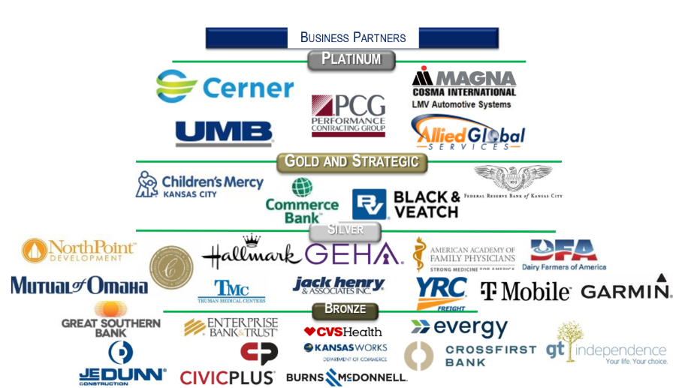

Our 70 plus partners in May 2022.
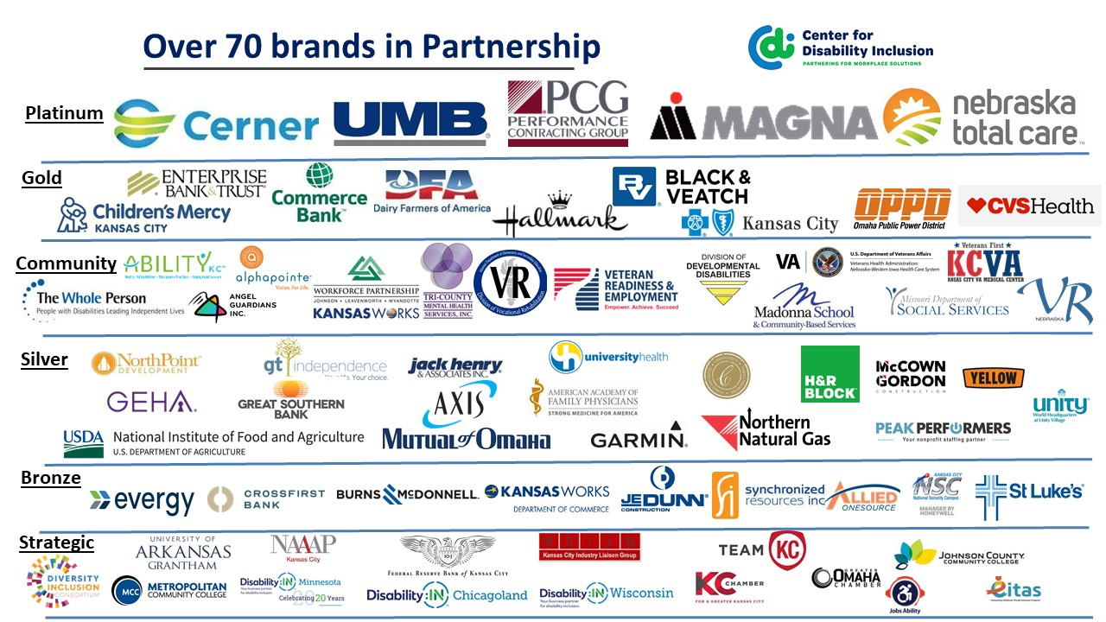

GuideStar platinum seal of transparency. We're pleased to announce the Center for Disability Inclusion ﻿has earned the GuideStar 2021 Platinum Seal of Transparency! ﻿Check out our GuideStar profile at https://www.guidestar.org/profile/26-4700449

Did You Know?
- 2022 Planning Resource Available. The 2022 Calendar of Disability Awareness-Related Dates helps you stay up-to-date on important events and be proactive and intentional in your disability events planning. Check it out on our Resources page at https://www.centerfordisabilityinclusion.org/resources.html.

- "Boost Your Job Search" Workshop on August 23. We are holding our second free virtual workshop ​for candidates with disabilities. Attendees receive guidance to maximize their online presence in Jobs Ability to accelerate their job search. Community agencies, colleges and universities - invite your clients and students with disabilities to register and participate at https://www.centerfordisabilityinclusion.org/boost-your-job-search-workshop---attend.html. Want to help support this program? Your $35 donation pays for one candidate to attend by covering costs for instructor time, and as applicable, meeting space and transportation. Click to following link to donate - https://www.centerfordisabilityinclusion.org/boost-your-job-search---support.html

Visit the CDI website at - https://www.centerfordisabilityinclusion.org/

To unsubscribe from CDI emails, please email Brenda Perkins at bperkins@centerfordisabilityinclusion.org

