Center for Disability Inclusion Monthly News & Updates for November 2022

CDI Fall Programs

- November 9 - 10:00 am Central. "Recruiting Veterans with Disabilities". This webinar is offered in collaboration with CDI and Disability:IN Chicagoland, Disability:IN Minnesota, Disability:IN DC-Metro and Disability:IN Wisconsin. Read more at https://www.centerfordisabilityinclusion.org/learning--development-programs.html

- November 15 - 9:00 am Central. Disability Inclusion Network Virtual Meeting featuring Blue Cross and Blue Shield of Kansas City and Peak Performers. These CDI partners will share their efforts, insights, challenges and successes. Read more at https://www.centerfordisabilityinclusion.org/upcoming-events.html

Register for 2022 Champions Celebration

- December 7 - 8:45-10:30 am Central. "Annual Champions Celebration Event" - Breakfast Program and Hybrid. In-person at the Federal Reserve Bank of Kansas City and virtual via Teams. Keynote presentation plus moderated panel with past Champion Award businesses sharing highlights of their work to advance disability inclusion in the workplace. Keynote “Disability Is My Culture” with Matthew Edwards, PhD. Panelists include: Performance Contracting Inc, Allied OneSource, Children’s Mercy KC, LMV Automotive/Magna, UMB Bank and others. Read more at https://www.centerfordisabilityinclusion.org/champions-celebration-event.html

Elevate Your Efforts with new CDI Seal of Accomplishment

Graphic of new seal with watermark of SAMPLE overlayed at the bottom of text – Leader in Disability Inclusion 2023

​This unique seal recognizes business and organization partners across the US who are leaders and influencers in advancing disability inclusion.

Recipients will have worked through the CDI proprietary Disability Inclusion Process, and earned the right to leverage brand recognition by posting it throughout their organization's media. ​This provides a proven roadmap for businesses in the completion of milestones ​resulting in ​outcomes that elevate disability inclusion ​in the workforce, workplace and marketplace. Getting started deadline for 2023 award process is February 1, 2023. Learn more at https://www.centerfordisabilityinclusion.org/seal-of-accomplishment.html

Did You Know?

During October, in celebration of National Disability Employment Awareness Month the CDI teame:

- made 20 presentations
- to 7 CDI Partner companies
- and 13 non-Partners
- with 1,010 total attendees
- across the US plus the UK

We're already planning ahead for 2023. Are you? To discuss your training needs contact Darla at dwilkerson@centerfordisabilityinclusion.org

Thank You to our Newest Partners:
- ONE Gas in Tulsa OK
- Children’s Hospital and Medical Center in Omaha NE

Thank You to our Renewing Partners:
- Tri-County Mental Health Services
- Kansas City VA Medical
- Johnson County Community College

Thank You to our Upgrading Partners:
- Honeywell National Security Campus in Kansas City

Year End Budgeting and CDI Partnership
- Are you working on your year end and 2023 budget?
- CDI would welcome the opportunity to be included in your DE&I efforts. To learn more about CDI partnership opportunities click here or contact Darla at dwilkerson@disabilityinclusion.org

Connect with us today on Facebook at https://www.facebook.com/centerfordisabilityinclusion and LinkedIn at https://www.linkedin.com/company/centerfordisabilityinclusion

Our 75 plus partners as of October 31, 2022.

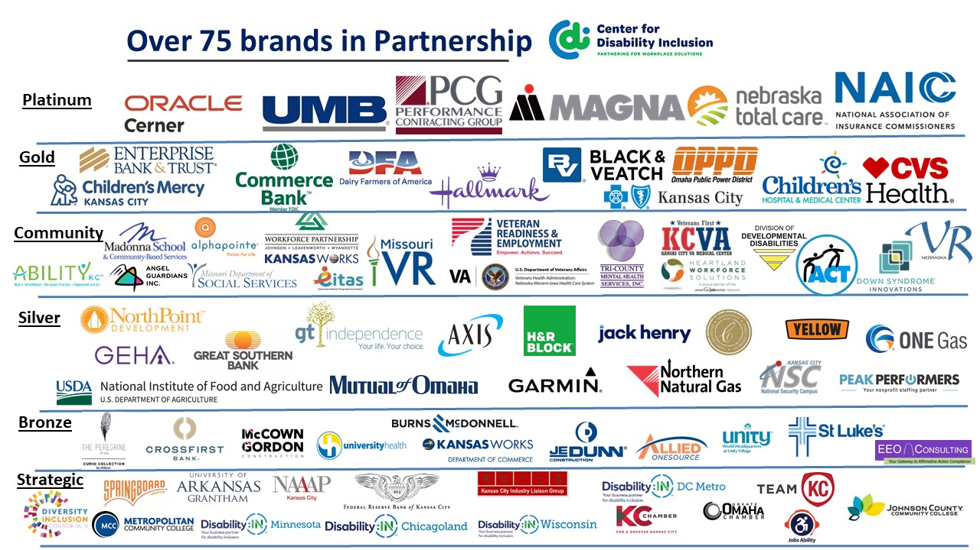

Visit the CDI website at - https://www.centerfordisabilityinclusion.org/

To unsubscribe from CDI emails, please email Brenda Perkins at bperkins@centerfordisabilityinclusion.org

