Center for Disability Inclusion Monthly News & Updates for November 2022

Our 8th Annual "Elevating Your Inclusion Journey" virtual Summit last month was a big success and included:
- 9 hours of learning
- 4 presentations
- 3 panel discussions
- 117 registered
- 62 companies represented
- 14 states represented
- 1 big announcement

Thank you to all who presented and attended.

New Seal of Recognition Announced

Graphic of new seal with watermark of SAMPLE overlayed on it – Leader in Disability Inclusion 2023

- Brand recognition, internal and external as a leader in advancing disability inclusion
- Expedite your customized disability inclusion process when you leverage the CDI team expertise as subject matter experts.
- Enhance your retention strategy and succession planning and increase your access to an untapped workforce.
- Peer recognition at annual Champions Celebration.
- Open to CDI Partners.
- Learn more

CDI Fall Programs

- October 12 - 1:30-2:30 pm Central. "Boost Your Job Search Workshop". Free virtual event for candidates with disabilities. Community agencies, colleges and universities, please invite your clients and students with disabilities to register and participate! Register at https://www.centerfordisabilityinclusion.org/boost-your-job-search-workshop---attend.html

- October 13 - 10:00 am Central - "Inclusive Leadership". Presenting at this webinar is Felecia Hogan, SVP and Director of Diversity, with Commerce Bank. Learn key principles about inclusive leadership and why it’s important in the pursuit of creating a sense of belonging for your teams. Read more at https://www.centerfordisabilityinclusion.org/learning--development-programs.html

- October 18 - 9:00 am Central. Disability Inclusion Network Virtual Meeting featuring CrossFirst Bank and ﻿UMB Bank. These CDI partners will share their efforts, insights, challenges and successes. Read more at https://www.centerfordisabilityinclusion.org/upcoming-events.html

- October 19 - 9:00-10:30 am Central. In-Person Networking Event at The Peregrine Hotel in Omaha Nebraska. Open to CDI Partners and guests. Beverages and light snacks provided. Read more at https://www.centerfordisabilityinclusion.org/upcoming-events.html

- November 9 - 10:00 am Central. "Recruiting Veterans with Disabilities". This webinar is offered in collaboration with CDI and Disability:IN Chicagoland, Disability:IN Minnesota, Disability:IN DC-Metro and Disability:IN Wisconsin. Read more at https://www.centerfordisabilityinclusion.org/learning--development-programs.html

- November 15 - 9:00 am Central. Disability Inclusion Network Virtual Meeting featuring Blue Cross and Blue Shield of Kansas City and Peak Performers. These CDI partners will share their efforts, insights, challenges and successes. Read more at https://www.centerfordisabilityinclusion.org/upcoming-events.html

Register for 2022 Champions Celebration

- December 7 - 8:45-10:30 am Central. "Annual Champions Celebration Event" - Breakfast Program and Hybrid. In-person at the Federal Reserve Bank of Kansas City and virtual via Teams. Keynote presentation plus moderated panel with past Champion Award businesses sharing highlights of their work to advance disability inclusion in the workplace. Keynote “Disability Is My Culture” with Matthew Edwards, PhD. Panelists include: Performance Contracting Inc, Allied OneSource, Children’s Mercy KC, LMV Automotive/Magna, UMB Bank and others. Read more at https://www.centerfordisabilityinclusion.org/champions-celebration-event.html

More Learning Sessions
- October 13 - 8:00-3:30 pm CT. "Disability:IN Wisconsin 2022 Summit", in-person at Rockwell Automation, Milwaukee WI. Read more at https://disabilityinwisconsin.org/2022-disability-in-wisconsin-summit/

- October 20 - 11:30-1:00 pm. "Practical Actions for Disability Inclusion Practices. Hybrid event offered by SHRM-JC. Lunch program at DoubleTree Hotel, Overland Park KS 66210; also online. Read more at https://www.centerfordisabilityinclusion.org/learning--development-programs.html

October ~ National Disability Employment Awareness Month

Observed annually in October, NDEAM celebrates the contributions of America’s workers with disabilities past and present, and showcases supportive, inclusive employment policies and practices. This year's theme "Disability: Part of the Equity Equation" recognizes the vital role people with disabilities play in a diverse and inclusive American workforce. Employers can do a lot to change this landscape and foster inclusion. Need resources to help your company recognize NDEAM? Read more at https://www.dol.gov/agencies/odep/initiatives/ndeam

Thank You to our Newest Partners:
- EEO Consulting
- Heartland Workforce Solutions

Thank You to our Renewing Partners:
- Black & Veatch
- Cosentino’s Food Stores

Year End Budgeting and CDI Partnership
- Are you working on your year end and 2023 budget?
- CDI would welcome the opportunity to be included in your DE&I efforts. To learn more about CDI partnership opportunities click here or contact Darla at dwilkerson@disabilityinclusion.org

Connect with us today on Facebook at https://www.facebook.com/centerfordisabilityinclusion and LinkedIn at https://www.linkedin.com/company/centerfordisabilityinclusion

Interested in Partnership with CDI?
We offer a variety of Partnership Options for business and community agencies. Select the level of benefits, consultation, online job board and other services that best fits your organization's disability inclusion focus. Want to learn more? Let's schedule an exploratory conversation. View your partnership options at – https://www.centerfordisabilityinclusion.org/partnership.html or email Darla Wilkerson, CEO at dwilkerson@centerfordisabilityinclusion.org

Our 70 plus partners as of September 2022.
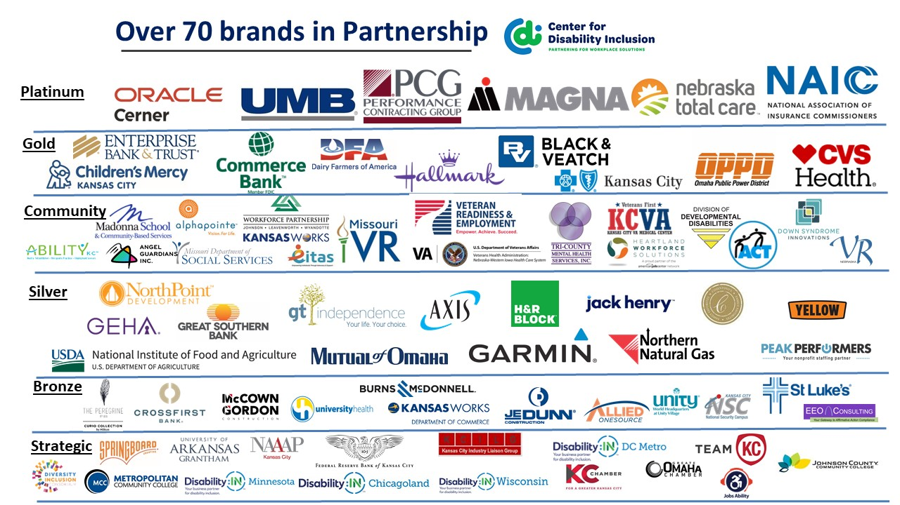

Visit the CDI website at - https://www.centerfordisabilityinclusion.org/

To unsubscribe from CDI emails, please email Brenda Perkins at bperkins@centerfordisabilityinclusion.org

