Center for Disability Inclusion Monthly News & Updates for September 2022

This is the last week to register for our 8th Annual Disability Inclusion Conference on
September 14-15, 2022.
Our virtual Annual Summit titled “Elevating Your Inclusion Journey” is one of the region's largest featuring national and regional experts on strategies and leading practices to advance disability inclusion in the workplace.

September 14 from 10:00 - 3:00 pm Central - Theme is "Charting Your Journey"
- Big Announcement from CDI
- Are We There Yet: Strategically Mapping Diversity and Disability
- Getting Equipped: A Guide for Navigating Today's Talent Challenges
- Building Your Team
- Best Practices in Elevating the Hiring Process

September 15 from 12:30 - 4:30 pm Central - Theme is "Elevating Your Journey"
- Launch Now: Starting a Disability Focused ERG/BRG
- Elevating Enterprise-Wide Accessibility
- IDEA: Inclusion, Diversity, Accessibility in the Workplace
- Moving Forward: Just Do Something

September 12 is deadline to register! Learn more and register at https://www.centerfordisabilityinclusion.org/disability-inclusion-summit.html

CDI Fall Programs

- September 21 - 10:00-11:30 am Central. Omaha NE In-Person Networking Event at The Peregrine Hotel. Open to CDI Partners and guests. Beverages and light snacks provided. Learn more and register at https://www.centerfordisabilityinclusion.org/upcoming-events.html

- October 12 - 1:30-2:30 pm Central. "Boost Your Job Search Workshop". Free virtual event for candidates with disabilities. Community agencies, colleges and universities, please invite your clients and students with disabilities to register and participate! Register at https://www.centerfordisabilityinclusion.org/boost-your-job-search-workshop---attend.html

- October 13 - 10:00 am Central - "Inclusive Leadership". Presenting at this webinar is Felecia Hogan, SVP and Director of Diversity, with Commerce Bank. Read more at https://www.centerfordisabilityinclusion.org/learning--development-programs.html

- October 18 - 9:00 am Central. Disability Inclusion Network Virtual Meeting featuring CrossFirst Bank and ﻿UMB Bank. These CDI partners will share their efforts, insights, challenges and successes. Read more at https://www.centerfordisabilityinclusion.org/upcoming-events.html

- October 19 - 9:00-10:30 am Central. In-Person Networking Event at The Peregrine Hotel in Omaha Nebraska. Open to CDI Partners and guests. Beverages and light snacks provided. Read more at https://www.centerfordisabilityinclusion.org/upcoming-events.html

- November 9 - 10:00 am Central. "Recruiting Veterans with Disabilities". This webinar is offered in collaboration with CDI and Disability:IN Chicagoland, Disability:IN Minnesota, Disability:IN DC-Metro and Disability:IN Wisconsin. Read more at https://www.centerfordisabilityinclusion.org/learning--development-programs.html

- November 15 - 9:00 am Central. Disability Inclusion Network Virtual Meeting featuring Blue Cross and Blue Shield of Kansas City and Peak Performers. These CDI partners will share their efforts, insights, challenges and successes. Read more at https://www.centerfordisabilityinclusion.org/upcoming-events.html

- December 7 - 8:45-10:30 am Central. "Annual Champions Celebration Event". This hybrid event will be in-person at the Federal Reserve Bank of Kansas City and virtual via Teams. Past recipients of the Champions Award and ​the work they've been doing to advance disability inclusion in the workplace will be highlighted. Read more at https://www.centerfordisabilityinclusion.org/champions-celebration-event.html

Other Fall Programs
- September 22 - 11:30 am - 1:00 pm CT. "Integrating Disability Owned Business Enterprises into Your Supply Chain". Webinar offered by Disability:IN Chicagoland, Disability:IN Wisconsin, Disability:IN Minnesota, Disability:IN DC Metro. Register at https://us02web.zoom.us/meeting/register/tZUqc-quqTIsG9ZaCiNz9cv7M4preG48vv-1

- September 28 - 3:30-5:30 pm ET. "The Future of Work: Returning to the Office Post COVID-19". Hybrid event offered by Disability:IN DC Metro and Deloitte. Read more at https://www.centerfordisabilityinclusion.org/learning--development-programs.html

- October 13 - 8:00-3:30 pm CT. "Disability:IN Wisconsin 2022 Summit", in-person at Rockwell Automation, Milwaukee WI. Read more at https://disabilityinwisconsin.org/2022-disability-in-wisconsin-summit/

- October 20 - 11:30-1:00 pm. "Practical Actions for Disability Inclusion Practices. Hybrid event offered by SHRM-JC. Lunch program at DoubleTree Hotel, Overland Park KS 66210; also online. Read more. Read more at https://www.centerfordisabilityinclusion.org/learning--development-programs.html

Thank You to our Newest Partner:
- Down Syndrome Innovations

Thank You to our Renewing Partners:
- CVS Health
- Performance Contracting Inc
- LMV Automotive Systems/Magna
- Ability KC
- CrossFirst Bank
- Alphapointe
- Mutual of Omaha
- USDA – National Institute of Food and Agriculture

Year End Budgeting and CDI Partnership
- Are you working on your year end and 2023 budget?
- CDI would welcome the opportunity to be included in your DE&I efforts. To learn more about CDI partnership opportunities click here or contact Darla at dwilkerson@disabilityinclusion.org

GuideStar platinum seal of transparency.
We're pleased to announce the Center for Disability Inclusion ﻿has earned the GuideStar 2021 Platinum Seal of Transparency! ﻿Check out our https://www.guidestar.org/profile/26-4700449GuideStar profile at https://www.guidestar.org/profile/26-4700449

Connect with us today on Facebook at https://www.facebook.com/centerfordisabilityinclusion and LinkedIn at https://www.linkedin.com/company/centerfordisabilityinclusion

Interested in Partnership with CDI?
We offer a variety of Partnership Options for business and community agencies. Select the level of benefits, consultation, online job board and other services that best fits your organization's disability inclusion focus. Want to learn more? Let's schedule an exploratory conversation. View your partnership options at – https://www.centerfordisabilityinclusion.org/partnership.html or email Darla Wilkerson, CEO at dwilkerson@centerfordisabilityinclusion.org

Our 70 plus partners as of August 2022.
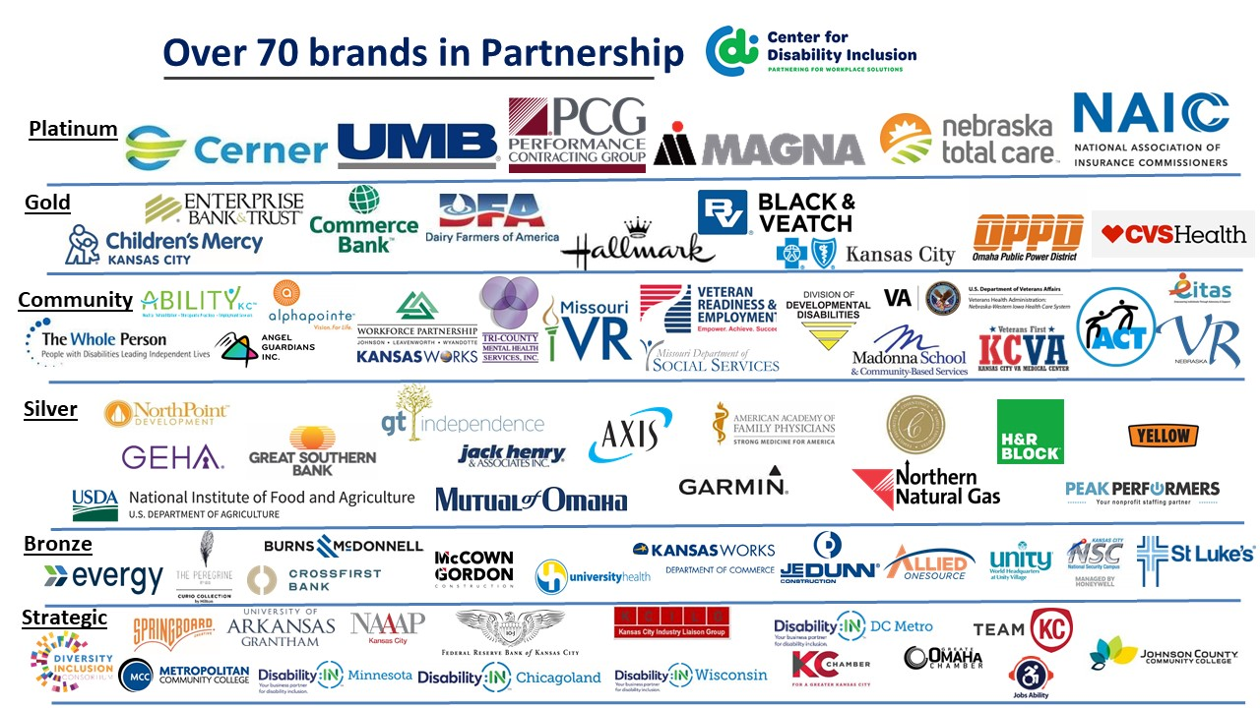

Visit the CDI website at - https://www.centerfordisabilityinclusion.org/

To unsubscribe from CDI emails, please email Brenda Perkins at bperkins@centerfordisabilityinclusion.org

