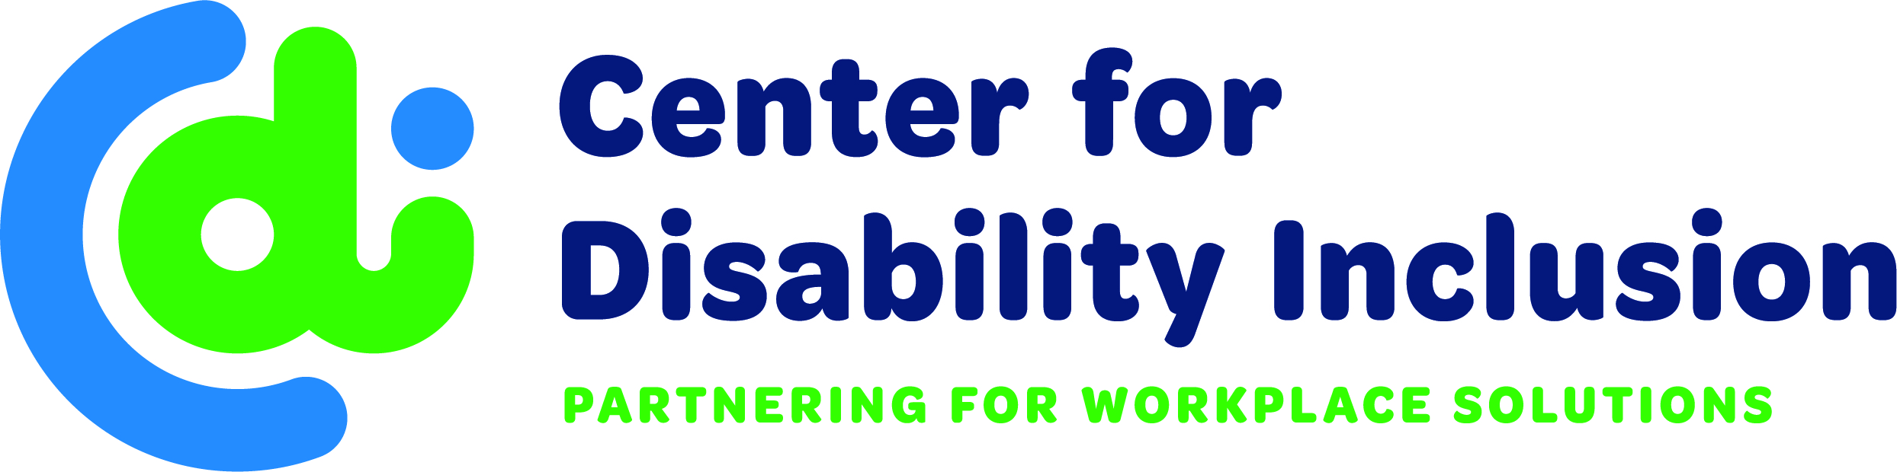

 | Programs  & Services | Tier 3  Serve 100+  Candidates per Year | Tier 2  Serve 50-100  Candidates per Year | Tier 1  Serve < 50  Candidates per Year
Jobs | Jobs Ability  (Online Job Board) | Unlimited local postings for your agency’s hiring needs.  Plus, unlimited  candidate access | Unlimited  candidate access | Unlimited  candidate access
Connect with Businesses | Disability Inclusion Network | 2 Attendees  at Monthly Meetings | 1 Attendee  At Monthly Meetings | 1 Attendee  at Monthly Meetings
 | Exhibit Space | At Designated Events | Addl. Fee Required | Addl. Fee Required
Education & Training | Disability Inclusion Summit | 2 Registrations and Listed as Supporting Sponsor | 1 Registration | Addl. Fee Required
 | Champions Awards Event | 2 Registrations and Listed as Supporting Sponsor | 1 Registration | Addl. Fee Required
 | Thought Leaders Event | 2 Registrations and Listed as Supporting Sponsor | 1 Registration | Addl. Fee Required
 | Educational Programs | 2 Registrations per Program and  discounted rates to Disability:IN Chicagoland, WI & MN events | 1 Registration per Program  and discounted rates to Disability:IN Chicagoland,  WI & MN events | 1 Registration per Program  and discounted rates to Disability:IN Chicagoland,  WI & MN events
 | Quarterly meetings | Quarterly connections  with peers and check in with CDI | Quarterly connections  with peers and check in  with CDI | Semi-Annual connections  with peers and check in  with CDI
 | Consulting/Staff Training | 4 Hours per Year | 2 Hours per Year | 1 Hour per Year
Brand Recognition | Company Logo on Website | Prominent Placement on Partner Page | Placement  on Partner Page | Placement  on Partner Page
 | Printed and Electronic Materials¹ | Prominent Placement of Logo on all Materials | Placement of Logo  on all Materials | Placement of Logo  on all Materials
ANNUAL INVESTMENT  (Optional to pay quarterly)  ¹ Printed and electronic materials include eblasts, event materials, marketing, signage, social media and more.  ² Discounted tuition rates at Grantham University (60+ degreed/certificate programs) for all employees of Partners.  We Welcome Your Partnership - www.CenterForDisabilityInclusion.org  Darla Wilkerson – dwilkerson@centerfordisabilityinclusion.org |  | $4,000  ($1,000/quarter) | $2,000  ($500/quarter) | $1,000  ($250/quarter)
Pivotal Partner Community Agency Options

