Center for Disability Inclusion News & Updates
for November 2023-January 2024
Alt Text Word Version

CDI news and updates will now be sent quarterly instead of monthly. Stay informed and connected about events and announcements when you follow us on LinkedIn at https://www.linkedin.com/company/centerfordisabilityinclusion/

CEO Position Announcement.
Darla Wilkerson is retiring at the end of 2023 and the Center for Disability Inclusion (CDI) is searching for our next CEO.
- This is an excellent opportunity for someone who is passionate about advancing disability inclusion.
- Join our national-based, business-led organization that helps companies advance their disability inclusion efforts in the workplace and marketplace.
- Assist us with sharing this opportunity within your professional network.
- If interested, visit the CDI website for downloadable position announcement and submit your resume. ​

Thank you. ​CDI Selection Committee.

Disability Inclusion Network Meetings.
This unique peer to peer Network builds relationships through monthly learning and open conversations that elevate awareness and change, break down barriers, and improve the hiring process and workplace for people with disabilities.

- August 15 – 9:00 am Central – “Comp & Benefits”
- August 23 – 9:30 am Central – Omaha Nebraska in-person meeting
- Read more at https://www.centerfordisabilityinclusion.org/upcoming-events.html

Expand your disability inclusion knowledge.
- Elevate your knowledge and understanding of disability inclusion in the workplace when you attend our learning and development programs.
- November 16 – 11:00 am Central - "Leveraging the Intersectionality of Veterans with Disabilities in Your Workplace”
- View our 2023 Schedule at https://www.centerfordisabilityinclusion.org/learning--development-programs.html

Save the Date for 2023 Inclusion Summit with theme of Amplifying Intersectionality.
- September 28-29, 2003. Live in Kansas City Missouri at the Federal Reserve Bank plus virtual via zoom. In-person seats are sold out. Unlimited virtual tickets are still available. Registration closes September 18at https://www.centerfordisabilityinclusion.org/attendees.html
- This collaborative national 2023 Inclusion Summit is led by the Center for Disability Inclusion in partnership with the DEI Consortium (KC), KC Chamber and NAAAP-KC (National Association of Asian American Professionals-Kansas City), centered around inclusion for all. Mark your calendar! read more at https://www.centerfordisabilityinclusion.org/inclusion-summit-2023.html
- The Inclusion Summit will present national keynote speakers who will challenge our thinking and regional subject matter experts sharing - and read more at https://www.centerfordisabilityinclusion.org/schedule.html
Elevate Your Efforts with CDI’s new Seal of Accomplishment.
Graphic of new seal for Leader in Disability Inclusion 2023 with watermark of SAMPLE overlayed at the bottom of text.
- Mark your calendar for December 1 Awards Event recognizing our 2023 Seal of Accomplishment Award recipients. Earlier this year, a number of our Partner companies committed to working the proprietary Disability Inclusion Process, designed by CDI, in an effort to earn the new Seal of Accomplishment Award. Recipient companies will have worked through the requirements and submitted an application demonstrating work done and progress made in 2023.
- Want to learn more and consider including the Seal in your 2024 effortts?
- Learn more at https://www.centerfordisabilityinclusion.org/seal-of-accomplishment.html

Resources to support your efforts.
Disability related events to acknowledge and celebrate in your organization.

- August - Spinal Muscular Atrophy Awareness Month. Aug 21 - National Senior Citizen's Day.
- September - Spinal Cord Injury & Pain Awareness Month; World Alzheimer's Month. Sept 21 - World Alzheimer's Day.
- October - National Disability Employment Awareness Month. Oct 10 - World Mental Health Day.
- Learn more on our Resources page at https://www.centerfordisabilityinclusion.org/resources.html

CDI Board welcomes new directors.
The CDI Board of Directors includes 15 business leaders from across the US. Welcome to our newest member, Jesus Vazquez, Director of Language & Accessibility Services with Children's Mercy Kansas City.

CDI Partnership Offers Tiered Options
CDI offers a variety of services to help organizations advance their efforts:
- Virtual and onsite Training on a variety of disability inclusion topics
- Fee-based Consultation around specific disability inclusion needs
- Tiered Partnership options for business and community agencies

You’ll be in good company with our 80+ partners. Learn more about partnership options and associated benefits at https://www.centerfordisabilityinclusion.org/business-partners.html

Thank You to our Newest Partners:
- WSIA Diversity Foundation
- Truman VA Hospital

Thank You to our Renewing Partners:
- Ability KC
- ACT Services
- Axis Capital
- Burns & McDonnell
- CrossFirst Bank
- Down Syndrome Innovations
- Eitas
- Great Southern Bank
- Missouri Division of Developmental Disabilities
- Missouri VR
- NAIC
- Nebraska VR
- Northen Natural Gas
- Oracle Cerner
- Performance Contracting Group

Connect with us today on LinkedIn at https://www.linkedin.com/company/centerfordisabilityinclusion

Graphic with small logos of our 80 plus partners as of July 31, 2023.

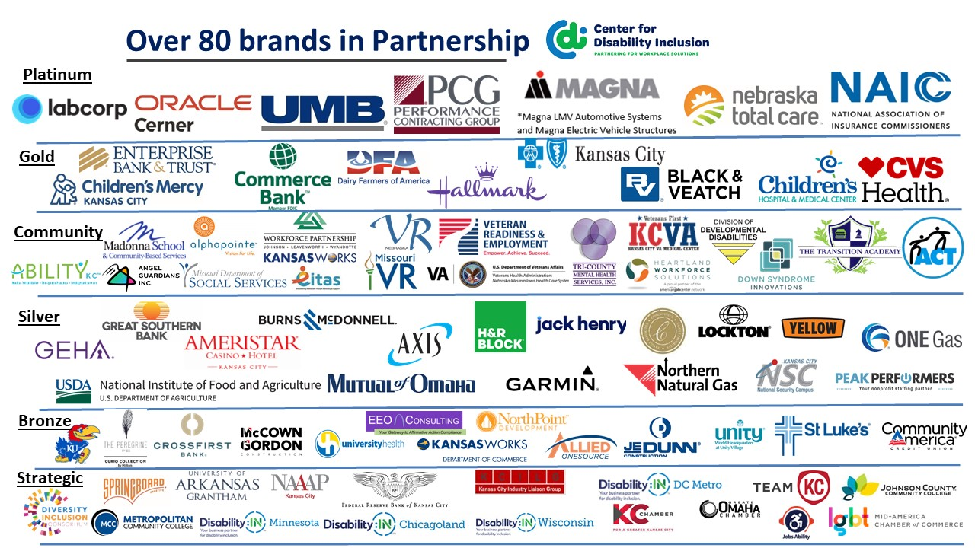

Visit the CDI website at - https://www.centerfordisabilityinclusion.org/

To unsubscribe from CDI emails, please email Brenda Perkins at bperkins@centerfordisabilityinclusion.org

