Center for Disability Inclusion News & Updates
for February, March and April 2023
Alt Text Word Version

CDI news and updates will now be sent quarterly instead of monthly. Stay informed and connected about events and announcements when you follow us on LinkedIn at https://www.linkedin.com/company/centerfordisabilityinclusion/

Connect and learn with peers.
- February 21 - 9:00 am Central. Disability Inclusion Network virtual meeting spotlighting Developmental Disability Awareness Month with CDI partner, Missouri Division of Developmental Disabilities. Read more at https://www.centerfordisabilityinclusion.org/upcoming-events.html

- February 22 – 9:30 am Central. Omaha Nebraska in-person Network Meeting hosted by CDI partner Mutual of Omaha. Panel discussion on “Developing a Disability ERG”. Read more at https://www.centerfordisabilityinclusion.org/upcoming-events.html

- March 21 – 9:00 am Central. Disability Inclusion Network virtual meeting. CDI community partners are inviting job seekers with disabilities to spotlight their job interests. Read more at https://www.centerfordisabilityinclusion.org/upcoming-events.html

- April 18 – 9:00 am Central. Disability Inclusion Network virtual meeting spotlighting St. Luke’s Health System Idaho and one other. Read more at https://www.centerfordisabilityinclusion.org/upcoming-events.html

Expand your disability inclusion learning.
- February 22 – 11:00 am Central. “Introduction to Illinois ABLE Accounts for Companies & Employees”. Virtual meeting offered by CDI collaborative partner Disability:IN Chicagoland. Partners register at no cost. Read more at https://www.centerfordisabilityinclusion.org/learning--development-programs.html

- February 22 – 12:00 pm Central. “Launching & Leveraging a Disability ERG/BRG”. Virtual meeting offered by CDI collaborative partner Disability:IN Minnesota. Read more at https://www.centerfordisabilityinclusion.org/learning--development-programs.html

Save the Date for 2023 Inclusion Summit – “Amplifying Intersetionality”
- September 28-29, 2003 in Kansas City Missouri. Registration Opens Soon!
- This collaborative national 2023 Inclusion Summit is led by the Center for Disability Inclusion in partnership with the DEI Consortium (KC), KC Chamber and NAAAP-KC (National Association of Asian American Professionals-Kansas City), centered around inclusion for all. Mark your calendar! read more at https://www.centerfordisabilityinclusion.org/inclusion-summit-2023.html

- Corporate Sponsorships Available for keynote speakers, session presenters and networking social to expand your brand visibility to this audience. To explore how your organization can support financially or in-kind, this collaborative national summit, contact Darla Wilkerson at dwilkerson@centerfordisabilityinclusion and read more at https://www.centerfordisabilityinclusion.org/inclusion-summit-2023.html

- The Inclusion Summit will present national keynote speakers who will challenge our thinking and regional subject matter experts sharing - read more at https://www.centerfordisabilityinclusion.org/inclusion-summit-2023.html

Elevate Your Efforts with CDI’s new Seal of Accomplishment
Graphic of new seal for Leader in Disability Inclusion 2023 with watermark of SAMPLE overlayed at the bottom of text.
- Congratulations to our inaugural group of 18 Partners across the country who have committed to working the Leader in Disability Inclusion Process in 2023. This proprietary process provides a customized roadmap for each partner to advance their efforts by focusing on intentional progress.
- Participating partners will submit an application in the Fall and Seals will be awarded in December to qualifying companies. Recipients will have completed milestones resulting in outcomes that elevate disability inclusion in the workforce, workplace and marketplace.
- ﻿Learn more at https://www.centerfordisabilityinclusion.org/seal-of-accomplishment.html

Plan your efforts with these resources.
Did you know there are many disability-related events your organization and Employee Resource Groups can recognize and celebrate during the year? Resources include: Extensive disability inclusion resources including articles, videos and links; Calendar of Disability-Related Events by month (US and global) and CDI 2023 Calendar of Events. Learn more on our Resources page at https://www.centerfordisabilityinclusion.org/resources.html

2022 Year In Review
What an exciting year for CDI with our national expansion and significant growth. Take a look at our metrics and impact at https://www.centerfordisabilityinclusion.org/2022-year-in-review.html

CDI Partnership Offers Tiered Options
CDI welcomes the opportunity to be included in your organization’s 2023 disability inclusion efforts.
You’ll be in good company with our 75+ partners Learn more about partnership options and associated benefits at https://www.centerfordisabilityinclusion.org/business-partners.html

Thank You to our Renewing Partners:
- UMB Bank
- Madonna School & Community Based Services

Connect with us today on LinkedIn at https://www.linkedin.com/company/centerfordisabilityinclusion

Our 75 plus partners as of January 31, 2023.

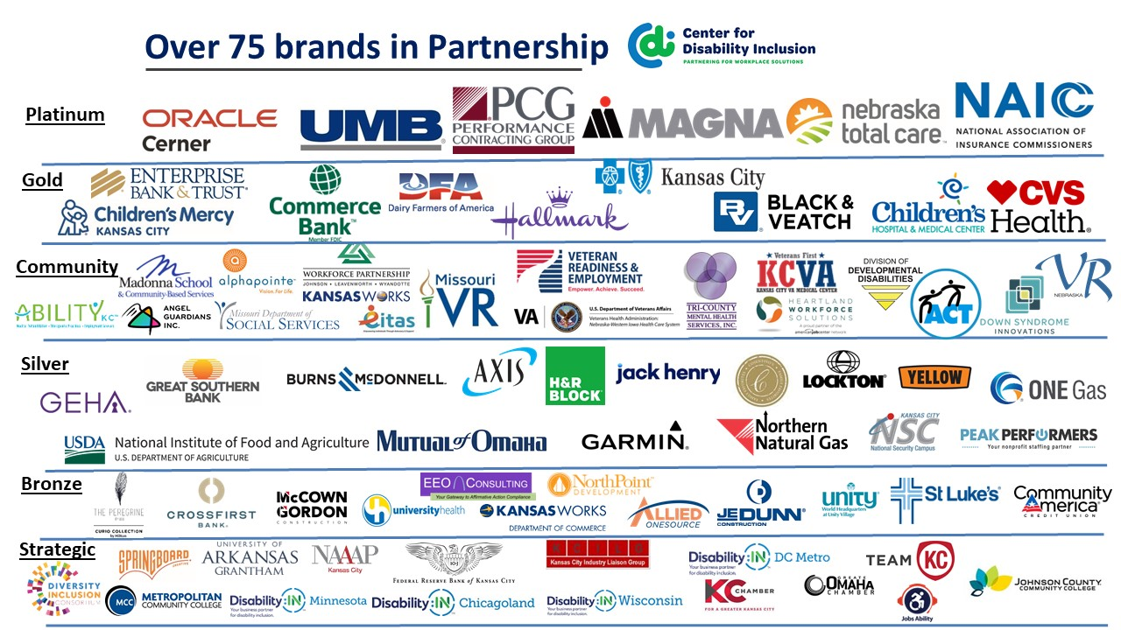

Visit the CDI website at - https://www.centerfordisabilityinclusion.org/

To unsubscribe from CDI emails, please email Brenda Perkins at bperkins@centerfordisabilityinclusion.org

