Center for Disability Inclusion News & Updates
for November 2023-January 2024
Alt Text Word Version

CDI news and updates will now be sent quarterly instead of monthly. Stay informed and connected about events and announcements when you follow us on LinkedIn at https://www.linkedin.com/company/centerfordisabilityinclusion/

Announcing Our New CEO.
I am pleased to announce that Meaghan Walls has been selected as the Center for Disability Inclusion’s next Chief Executive Officer and will start in this new role on December 23, 2023.

Darla Wilkerson is retiring in December after serving CDI for nine years including five years in the CEO role. Darla made a significant impact in helping develop CDI’s vision, direction and overall success of the organization. In the remaining weeks of 2023, she will work with Meaghan and the CDI team to ensure a smooth and successful leadership transition. Darla’s leadership and contributions to CDI are countless and she will be missed.

Meaghan joined CDI two years ago as the Director of Business Relations in our Nebraska market. The CDI Board of Directors are excited about the skills and experiences she will bring to the CEO role. Meaghan has over 17 years of professional experience with disability services, accessibility and disability inclusion. She is an alumni of Saint Mary’s College-Notre Dame and earned her Masters of Science from University of Illinois-Chicago (UIC) in Bioengineering with an emphasis on rehabilitation and assistive technology.

Please join me in welcoming Meaghan Walls as our next Chief Executive Officer.

Kathy Cooper, CDI Board President

Annual Awards Event
Register by November 21 for our Annual Awards Event on December 1 from 11:00 am to 1:30 pm Central with keynote presentation "The Power of Allyship: Building Stronger, Inclusive Communities" and recognition of 2023 Seal of Accomplishment Leader in Disability Inclusion Award recipients. Attendees with Partner companies receive free registration(s) and guests are welcome. Learn more and register at https://www.centerfordisabilityinclusion.org/annual-awards-event.html

Want to learn more about including the Disability Inclusion Process in your 2024 efforts? Contact Meaghan Walls at mwalls@centerfordisabilityinclusion.org

Disability Inclusion Network Meetings.
These peer to peer Network sessions help attendees build relationships ​through interactive learning and conversations that elevate awareness and improve the hiring process and workplace ​for people with disabilities. View upcoming schedule of events at
https://www.centerfordisabilityinclusion.org/upcoming-events.html

Expand your disability inclusion knowledge.
Join upcoming webinar on November 16 at 11:00 CST: "Leveraging Intersectionality of Veterans with Disabilities in the Workplace”. This moderated panel discussion will explore utilizing SkillBridge to leverage talent and intersectionality of veterans with disabilities ﻿in the workplace. Learn more and register at https://www.centerfordisabilityinclusion.org/learning--development-programs.html

CDI Impact By the Numbers
- The past two months, CDI has had significant impact with the 2023 Inclusion Summit in September and National Disability Employment Awareness Month (NDEAM) in October.
- 2023 Inclusion Summit Recap:
  - 296 - Attendees
  - ​142 - Companies
  - 24 - States
  - 19 - Sponsors
  - 11 - Speakers
  - 2 - Countries
  - 1 - Amazing DEIA Conference
  - Planning has already started for the 2024 Inclusion Summit. More info coming soon!

- 2023 NDEAM Recap:16 separate trainings completed by CDI team to elevate awareness of disability inclusion in the workplace.
  - "Workplace Practices" - 9
  - "Disability Awareness" - 2
  - "Disability Awareness for Persons with Disabilities" - 1
  - "Disability Awareness for College Students" - 1
  - "Neurodiversity in the Workplace" - 1
  - "Reducing Stigma of Mental Illness" - 1
  - "Event Accessibility" - 1

New Online Job Board Coming Soon
As we continue serving business partners in all aspects of their disability inclusion efforts,
we are close to launching a new online job board that will simplify how businesses and candidates with disabilities connect. ﻿Available to CDI Partners at Silver and above, for enterprise-wide use at no additional cost. Not a Partner? Check out your partnership options at https://www.centerfordisabilityinclusion.org/partnership.html and if interested, contact us for an exploratory conversation at bperkins@centerfordisabilityinclusion.org

Resources to Support Your Efforts.
Disability related events to acknowledge and celebrate in your organization. Check out our extensive library of resources when you need answers quickly.
- November - Natl Diabetes Awareness Month, Epilepsy Awareness Month
- December 3 - International Day of Persons with Disabilities
- January - National Glaucoma Awareness Month
- Learn more on our Resources page at https://www.centerfordisabilityinclusion.org/resources.html

CDI Partnership Offers Tiered Options
CDI offers a variety of services to help organizations advance their efforts. We hope you’ll consider CDI in your 2024 budget and planning:
- Virtual and onsite Training on a variety of disability inclusion topics; visit https://www.centerfordisabilityinclusion.org/training.html
- Fee-based Consultation around specific disability inclusion needs
- Tiered Partnership options for business and community agencies. You’ll be in good company with our 80+ partners. Learn more at https://www.centerfordisabilityinclusion.org/business-partners.html

Thank You to our Newest Partners:
- DMK Consults
- Council of Michigan Foundations

Thank You to our Renewing Partners:
- Angel Guardians
- Beacon Mental Health
- Black & Veatch
- Children’s Mercy KC
- Children’s Nebraska
- Cosentino’s Food Stores
- EEO Consulting
- Garmin
- GEHA
- Heartland Workforce Solutions
- Johnson County Community College
- Kansas City Natl Security Campus (Honeywell)
- Kansas City VA Medical Center
- Mutual of Omaha
- Rehabilitation Services for the Blind
- USDA-NIFA

Connect with us today on LinkedIn at https://www.linkedin.com/company/centerfordisabilityinclusion

Graphic with small logos of our 80 plus partners as of July 31, 2023.

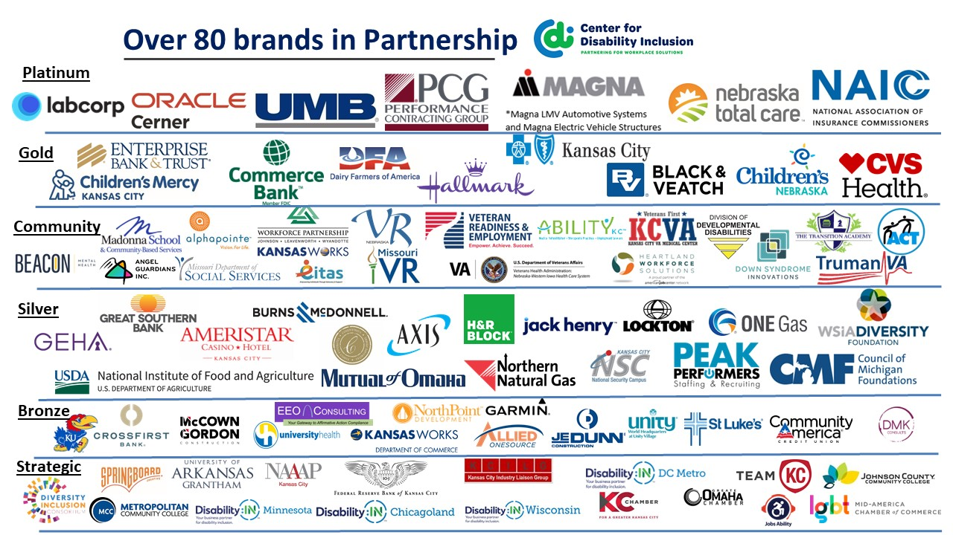

Visit the CDI website at - https://www.centerfordisabilityinclusion.org/

To unsubscribe from CDI emails, please email Brenda Perkins at bperkins@centerfordisabilityinclusion.org

