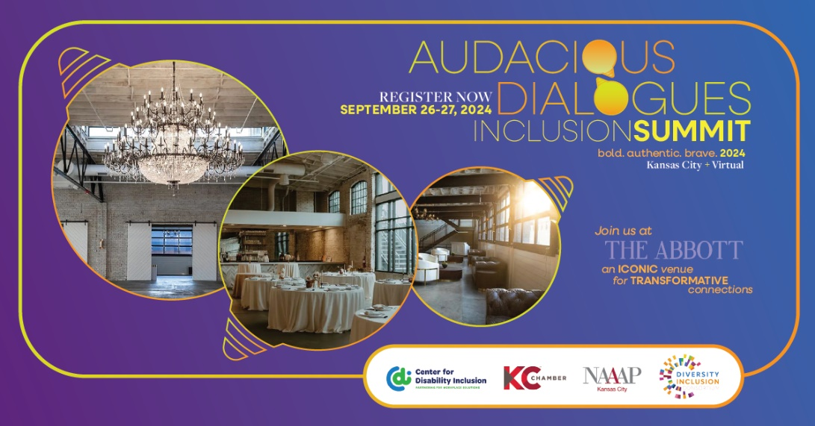

Conference Registration Info

INVESTMENT FOR THE TWO-DAY CONFERENCE
- Early Bird Fee – $299/attendee (3/18/24 thru 6/30/24)
- Regular Fee – $349/attendee (7/1/24 thru 9/12/24 or when sold out)
- Virtual Two-Day Fee -$225/attendee (3/18/24 thru 9/25/24)
- Virtual One-Day Fee - $125/attendee (3/18/24 thru 9/25/24)

Please Note:
- Registrations are for the sole use of the individual whose name is listed on the original registration. Registrations for the Inclusion Summit cannot be shared or split between individuals. There will be no exceptions to this policy.
- There are no one-day registration options.

REGISTRATION INCLUDES
The conference registration includes attendance to all conference sessions, conference materials, refreshment breaks, networking social, and all conference provided meals.

REGISTRATION TERMS & CANCELLATION POLICY
Once we have received your registration form, you will be responsible to pay the conference registration fee based on the Registration Terms & Cancellation Policy.
The cancellation deadline is September 9, 2024. Cancellations must be made in writing by September 9, 2024, to receive a refund, minus a $150 cancellation fee. Registrations who do not cancel prior to September 9, 2024, will be liable for the full registration fee. Non-payment or non-attendance does not constitute cancellation. No refunds will be processed prior to the event.

REGISTRATION CONFIRMATION POLICY
If you need to confirm your registration or have questions, please contact bperkins@centerfordisabilityinclusion.org. Do not register a second time. A refund will be processed minus the online processing fees. No refunds processed prior to the event.

TRANSFER OF REGISTRATION
If you register and are unable to attend, you may substitute another person in your place. Only full registration transfers are allowed. Please email bperkins@centerfordisabilityinclusion.org for instructions on how to transfer your registration. This information must be provided for the new individual to attend.

PLEASE NOTE: Registrations are for the sole use of the individual whose name is listed on the original registration. Registrations for the Inclusion Summit cannot be shared or split between individuals. There will be no exceptions to this policy.

IMAGE USE POLICY
Registration to The Inclusion Summit events and activities constitutes an agreement by the attendee to the Inclusion Summit’s use and distribution, both current and future, of the attendee’s image or voice in photographs, videotapes, electronic reproductions and audiotapes of such events and activities. Attendees waive any right to inspect or approve the finished materials and agree that all such pictures, video or audio recordings, and any reproduction thereof, shall remain the property of The Inclusion Summit to use at its discretion. Consent is binding, perpetual and may not be revoked.

ACCOMMODATIONS
If you have a disability and need an accommodation in order to attend this conference, please contact us as soon as possible. Contact Darla Wilkerson at mwalls@centerfordisabilityinclusion.org

