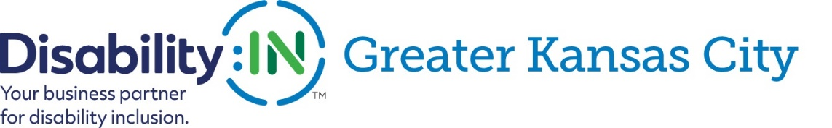
2021
Sponsorship Opportunities
Benefits from Sponsorship:
- Promotions through the web, social media, e-announcements, and printed materials distributed to partners and visitors at events.
- Opportunity to spot promote your company at sponsored events.
- Promote your brand as an employer of choice for people with disabilities.
Become an official event sponsor today!

Sponsorship Options
- Principal – annual sponsorship of $25,000 that covers two main events: Disability Inclusion Summit and Educational Programs/Webinars.
- Major – annual sponsorship of $10,000 that supports keynote speakers, and the Kansas City Disability Inclusion Network.
- Supporting – event sponsorship of $5,000 to cover featured speakers at Thought Leaders or Disability Champions Award Events.
- Ally – general sponsorship of $2,500 to provide “stipends” for individuals with disabilities to attend signature events.
Contact us to discuss a custom package that meets your budget and promo needs.
ARE YOU IN?
For details contact Darla Wilkerson at 816-284-3224 or darla@disabilityin-gkc.org and visit our website at www.disabilityin-gkc.org | Pay online at https://www.disabilityin-gkc.org/business-partners.html or by check to Disability:IN GKC, PO Box 901296, Kansas City MO 64190

